**ABSTRACT**

The main objective of the portfolio management system is to design and develop a web service which is useful for the job seekers and the job providers to meet.

Here, the database is used to collecting all the personal information of the candidate for generating their resume profile on the portal. The system admin will generate a report according to the company need and requirements.

1. **INTRODUCTION**

**1.1 Project Description**

* Portfolio Management system refers to a building a strong resume for the candidate who are seeking the jobs online.
* This system introduced the way of hiring the employees for the organization that contains all the information of the employees and according to their skill and job requirements, they get selected in the particular post.
* The purpose of Portfolio management is the selection, prioritization and control of an organization's programmed and projects, in line with its strategic objectives and capacity to deliver.

1. **ENVIRONMENTAL DESCRIPTION**

**2.1 Project Profile**

|  |  |
| --- | --- |
| **Project Information** | **Description** |
| Project Title | Portfolio Management System |
| Application Type | Web Application |
| Guided By | Asst. Prof. Rushabh Shah |
| Group Size | 2 |
| Team Members | * Sagar M. Pipaliya 19MCA028 * Nikunj N. Katariya 19MCA010 |

**2.2 Tools and Technologies**

|  |  |
| --- | --- |
| **Tools and Technology** | **Description** |
| Front End | PHP (7.2) |
| Back End | MySQL (8.0) |
| Web Server | Apache XAMPP |
| Other tools | * MS Word and PowerPoint (2016) * Sublime text 3 (3.2.2) * Creatly (for diagrams) |

1. **PROPOSED SYSTEM**

**3.1 Scope**

Portfolio system is a dynamic and continuous process. Following are the scopes of the portfolio management:

* Monitoring the performance of the portfolio by incorporating the latest conditions.
* Identifying the objectives, preferences and constraints.
* Compare with the latest targets and achievements.
* There is no need of keeping a physical resume for the candidate.
* Users have their own login ID and password, with which they can secure their documents.
* If a wrong password is given three times in succession, that user account will be locked and the user will not be able to use it.
* Once provided with internet access, users can take part in the system from everywhere.

**3.2 Project Modules**

**User: -**

* Users have to register into the system first.
* Users can provide their achievements, resume and skills in extra details.
* Users have to login into the system.
* Users can view their portfolio according to their details.
* Users can change their details in the system.
* Users can provide feedback to the organizations.

**Admin: -**

* Admin have to login in the system.
* Admin can view/block the latest registered details.
* Admin can filter the details.
* Admin can search the candidate by their skills, name, achievements and degree.
* Admin can select appropriate candidates.
* Admin can generate the reports.

**3.4 System Advantages**

* Building a resume online may saves your time that can be utilized in a better way.
* Candidates may instantly customize their details in the one click or add some new details with the same.
* The site built a confidence to boost since you can make your resume professional and you may able to impress the recruiters with your resume.
* Since admin can generate reports the process of selecting candidates will be easy.
* System is used to make smart and effective decisions for the organizations while selecting a candidate.
* System provides more accurate and user performance data.
* The system is helpful to achieve the better productivity in the organization.

**3.3 System Requirements**

1. **Functional Requirements: -**

* **Administrator: -** Responsible for managing clients of the system, taking system backup, generating reports, maintaining organization whole details.
* **Manage Users: -** The administrator can manage the user information and admin can mail and send the details to the appropriate user.
* **Maintain Details: -** The administrator maintains entire details of the system including details of the users.
* **Taking System Backup: -** The administrator takes backup of the database in order to prevent loss of the data on system crashes. He takes backup of the entire database in a particular section.
* **Generate Reports: -** Responsible for checking the logs of different system users for auditing and maintaining the whole system.
* **Use Registration & Login: -** The first thing is to register yourself by giving proper mail id and password then move forward to login into the system.
* **Filtering as per need: -** The administrator can filter the candidate & can view the information related to the filtering.

1. **Non – Functional Requirements: -**

* **User Interactive: -** The response of the website should be high and the website should behave as per the user action. Users should be acknowledged in the form of visual changes or feedback on the site to enhance the interaction. Portal should be maintained across all the web pages.
* **Security: -** Secure login option to the users to avoid unauthorized access to the system and the information. Advanced encryption algorithms must be integrated in the site to avoid misuse of the data sets.
* **Reliability: -** Portal should provide the users with valid information at all times.
* **Business Rules: -** This requirement contains all the rules and regulations on behalf of the system.

1. **DETAIL PLANNING**
   1. **Use case diagram**

* **Admin**

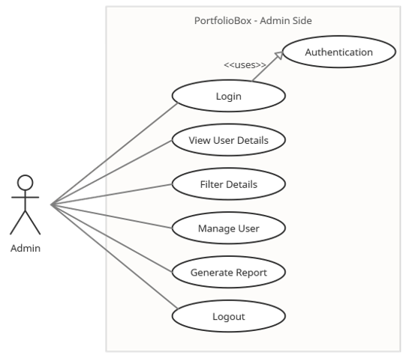

* **User**

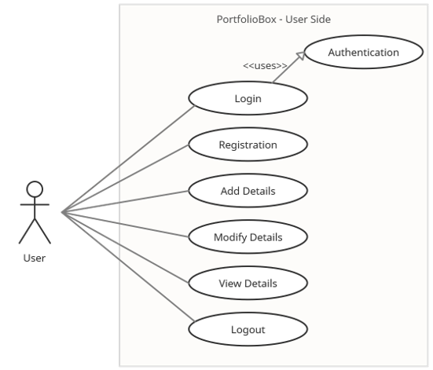

* 1. **Activity Diagram**
* **Admin**

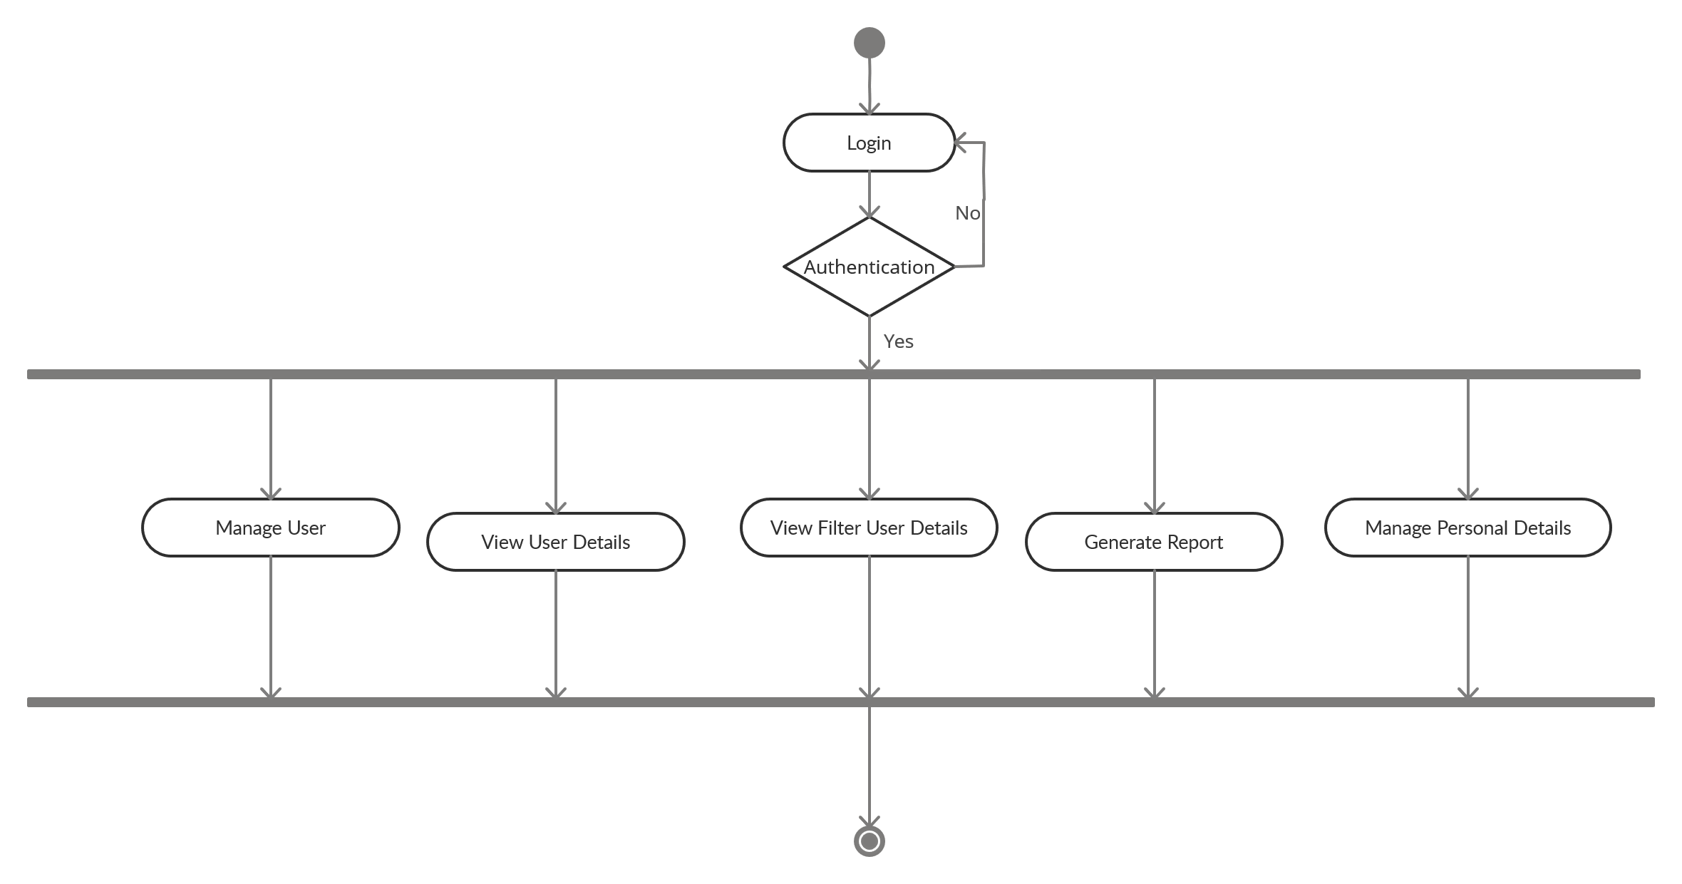

* **User**

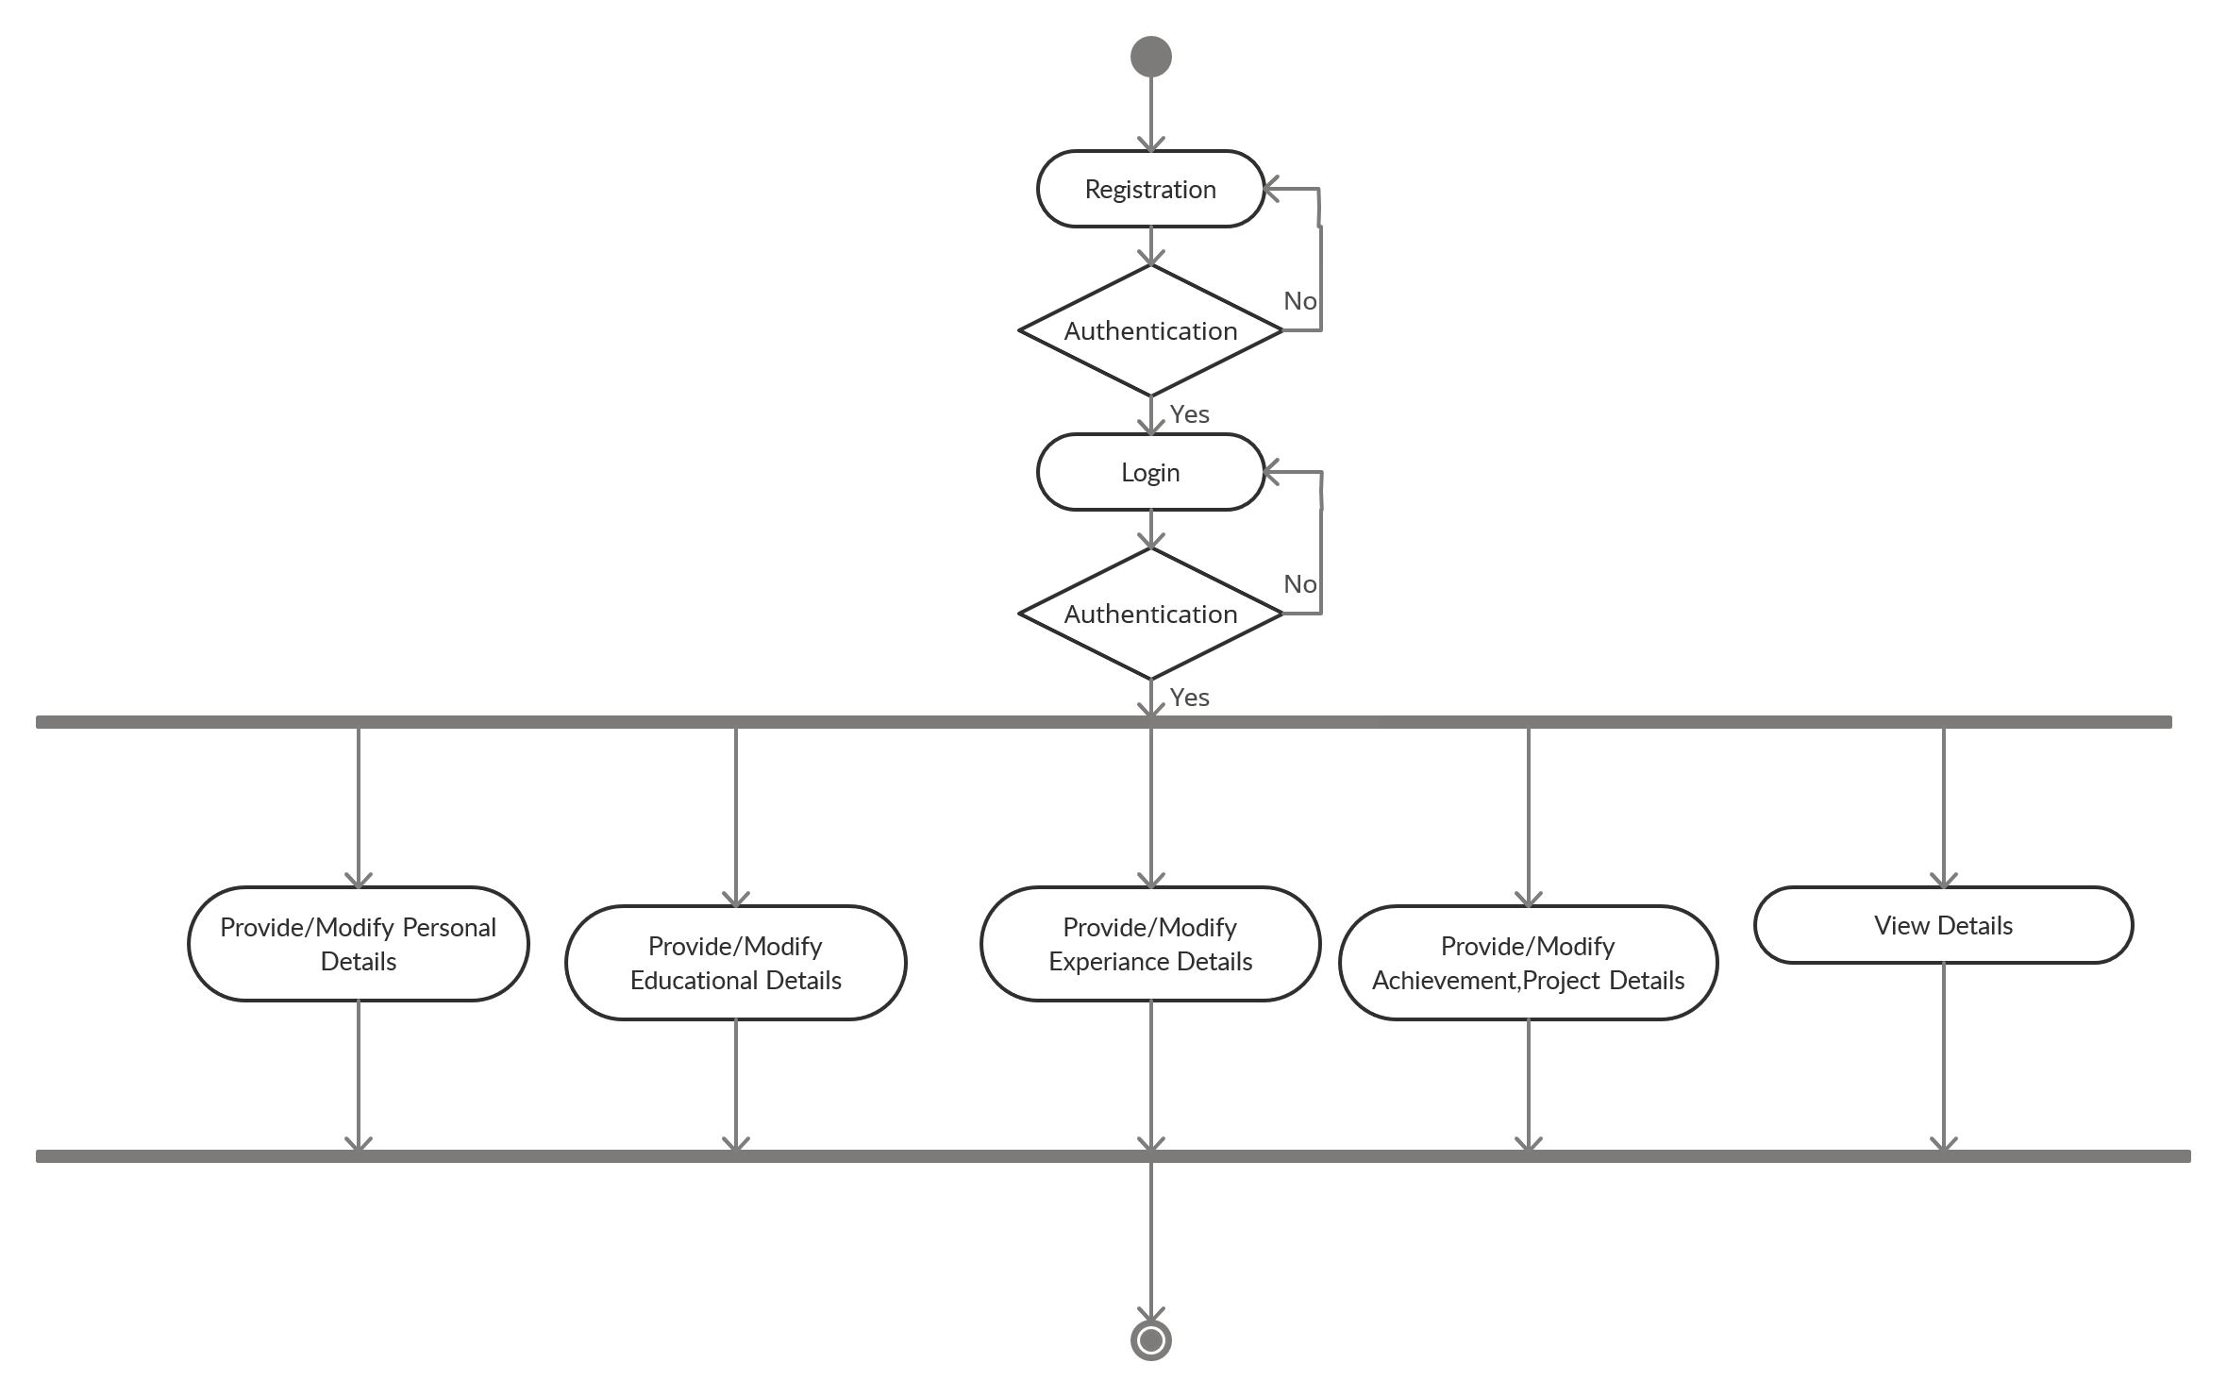

* 1. **Sequence Diagram**
* **User: -**

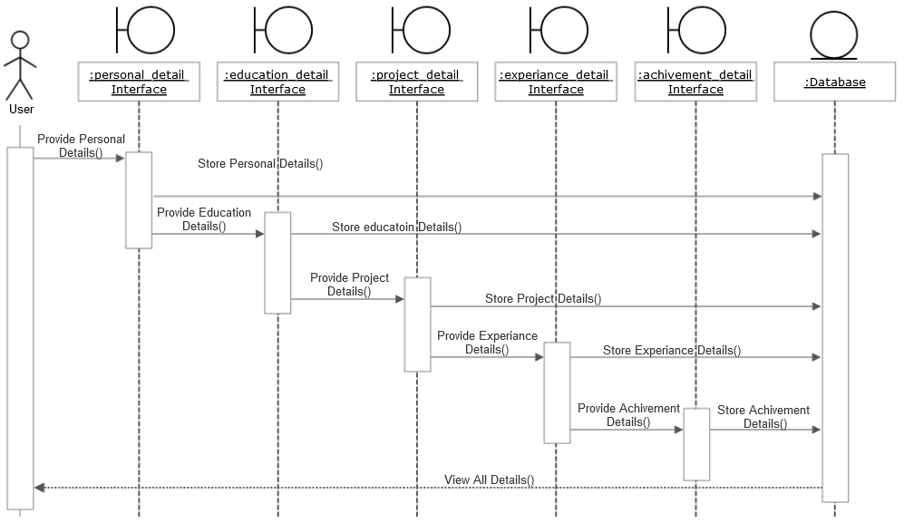

* 1. **State Chart Diagram**

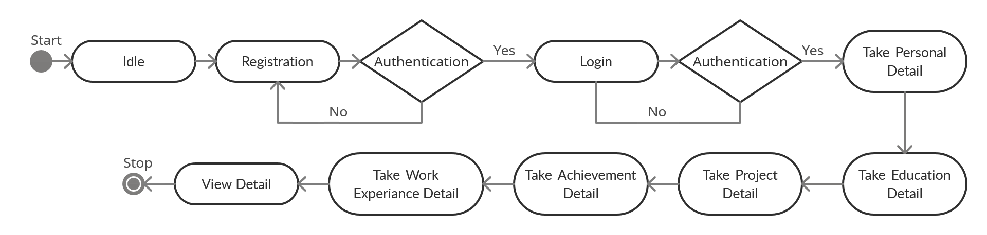

* 1. **Class Diagram**

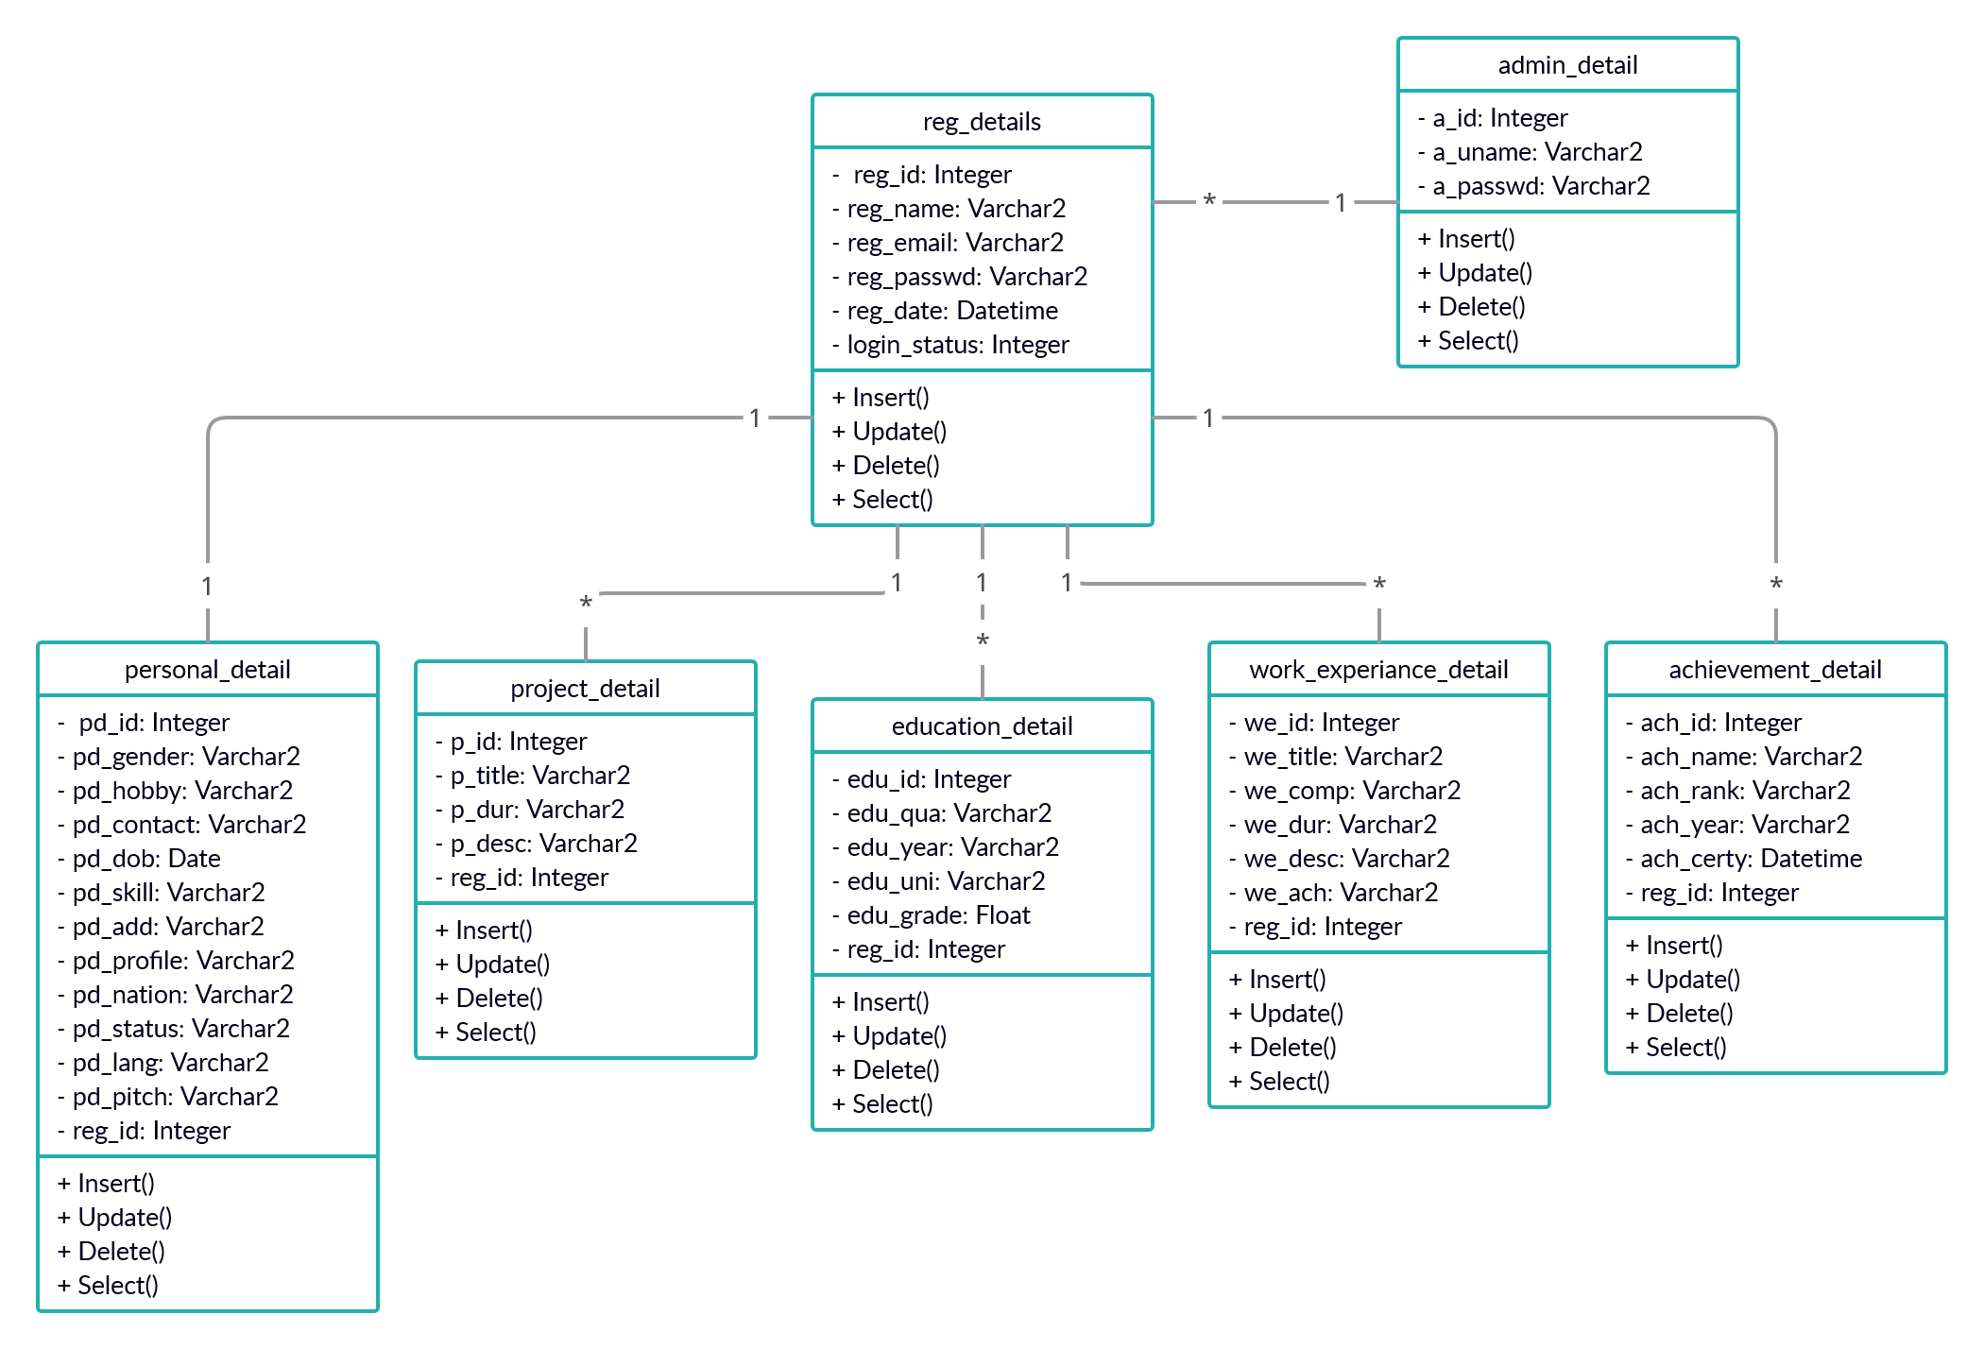

1. **SYSTEM DESIGN**
   1. **Database Design**

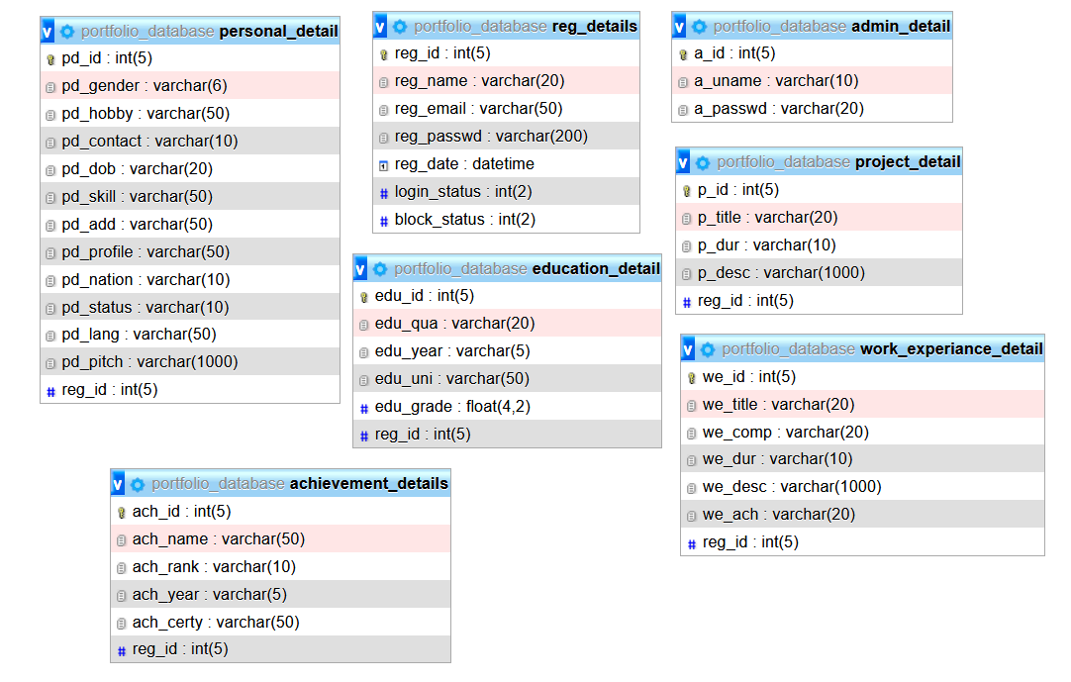

* 1. **Data Dictionary**
* **Reg_details**

|  |  |  |  |  |  |
| --- | --- | --- | --- | --- | --- |
| **No** | **Columns** | **Data Type** | **Size** | **Null** | **Details** |
| **1.** | reg_id | Integer | 5 | No | Primary key |
| **2.** | reg_name | Varchar2 | 20 | No | Name of user |
| **3.** | reg_email | Varchar2 | 20 | No | Email of user |
| **4.** | reg_passwd | Varchar2 | 20 | No | Password set by the user |
| **5.** | reg_date | Datetime |  | No | Registration Date of User |
| **6.** | login_status | Integer | 2 | No | Login Status |
| **7.** | block_status | Integer | 2 | No | User blocking status |

* **Admin_details**

|  |  |  |  |  |  |
| --- | --- | --- | --- | --- | --- |
| **No** | **Columns** | **Data Type** | **Size** | **Null** | **Details** |
| **1.** | a_id | Integer | 5 | No | Primary key |
| **2.** | a_uname | Varchar2 | 20 | No | Username of admin |
| **3.** | a_passwd | Varchar2 | 20 | No | Password of admin |

* **Personal_details**

|  |  |  |  |  |  |
| --- | --- | --- | --- | --- | --- |
| **No** | **Columns** | **Data Type** | **Size** | **Null** | **Details** |
| **1.** | pd_id | Integer | 5 | No | Primary key |
| **2.** | pd_gender | Varchar2 | 2 | No | Gender of user |
| **3.** | pd_hobby | Varchar2 | 50 | No | Hobbies of user |
| **4.** | pd_contact | Varchar2 | 10 | No | Contact detail of a user |
| **5.** | pd_dob | Date |  | No | User Birthdate |
| **6.** | pd_skill | Varchar2 | 50 | No | Technical skills of user |
| **7.** | pd_add | varchar2 | 50 | No | Address of a user |
| **8.** | pd_profile | varchar2 | 50 | No | Profile photo of user |
| **9.** | pd_nation | varchar2 | 10 | No | Nationality of user |
| **10.** | pd_status | varchar2 | 10 | No | Marital status of user |
| **11.** | pd_lang | varchar2 | 50 | No | Languages known |
| **12.** | pd_pitch | varchar2 | 50 | No | Short pitch about user |

* **Educational_details**

|  |  |  |  |  |  |
| --- | --- | --- | --- | --- | --- |
| **No** | **Columns** | **Data Type** | **Size** | **Null** | **Details** |
| **1.** | edu_id | Integer | 5 | No | Primary key |
| **2.** | edu_qua | Varchar2 | 20 | No | Qualification details |
| **3.** | edu_year | Varchar2 | 5 | No | Passing Year |
| **4.** | edu_uni | Varchar2 | 50 | No | Name of School/University |
| **5.** | edu_grade | float | 4,2 | No | Grade of user |
| **6.** | reg_id | Integer | 5 | No | Reference from reg_detail |

* **Achievement_details**

|  |  |  |  |  |  |
| --- | --- | --- | --- | --- | --- |
| **No** | **Columns** | **Data Type** | **Size** | **Null** | **Details** |
| **1.** | ach_id | Integer | 5 | No | Primary key |
| **2.** | ach_name | Varchar2 | 50 | No | Name of Achievement |
| **3.** | ach_rank | Varchar2 | 10 | No | Rank of user achievement |
| **4.** | ach_year | Varchar2 | 5 | No | Year of achievement |
| **5.** | ach_certy | Varchar2 | 50 | No | Certification of user |
| **6.** | reg_id | Integer | 5 | No | Reference from reg_detail |

* **Work_experiance_detail**

|  |  |  |  |  |  |
| --- | --- | --- | --- | --- | --- |
| **No** | **Columns** | **Data Type** | **Size** | **Null** | **Details** |
| **1.** | we_id | Integer | 5 | No | Primary key |
| **2.** | we_title | Varchar2 | 20 | No | Position of user |
| **3.** | we_comp | Varchar2 | 20 | No | Name of the company |
| **4.** | we_dur | Varchar2 | 10 | No | Working duration |
| **5.** | we_desc | Varchar2 | 50 | No | Company profile |
| **6.** | we_ach | Varchar2 | 20 | No | Achievement of a user |
| **7.** | reg_id | Integer | 5 | No | Reference from reg_detail |

* **Project_details**

|  |  |  |  |  |  |
| --- | --- | --- | --- | --- | --- |
| **No** | **Columns** | **Data Type** | **Size** | **Null** | **Details** |
| **1.** | p_id | Varchar2 | 5 | No | Primary key |
| **2.** | p_title | Varchar2 | 20 | No | Title of a project |
| **3.** | p_dur | Varchar2 | 10 | No | Project duration |
| **4.** | P_desc | Varchar2 | 50 | No | Project description |
| **5.** | reg_id | Varchar2 | 5 | No | Reference from reg_detail |

* 1. **Input/Output Design**
* **User side: -**
* **Login Page**

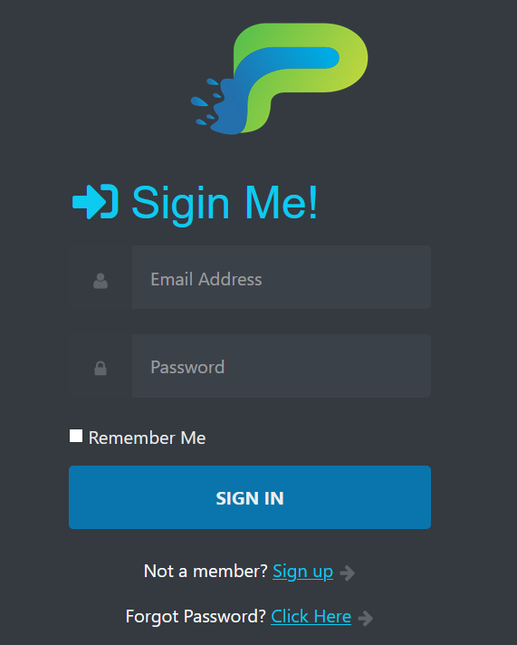

* **Login with invalid email and password**

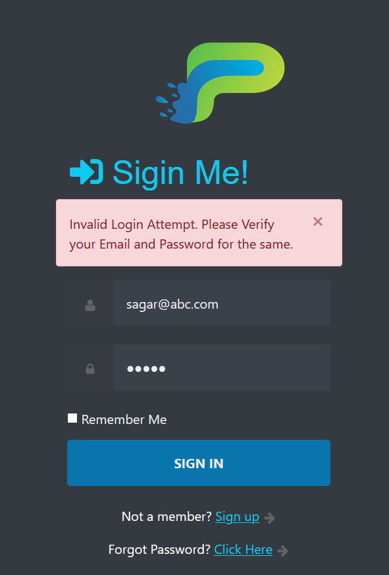

* **Forgot Password with some validations**

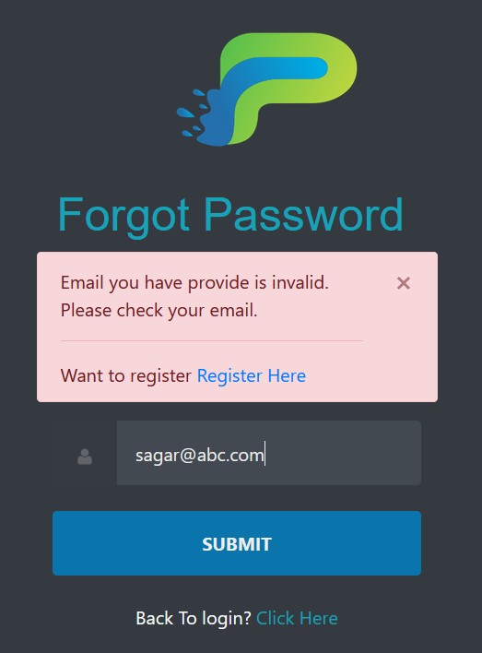

* 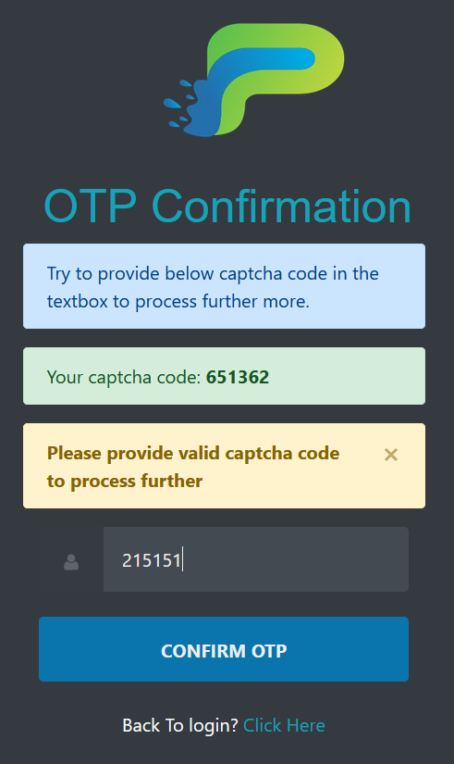 **Invalid captcha code provide**
* **Invalid confirm password**

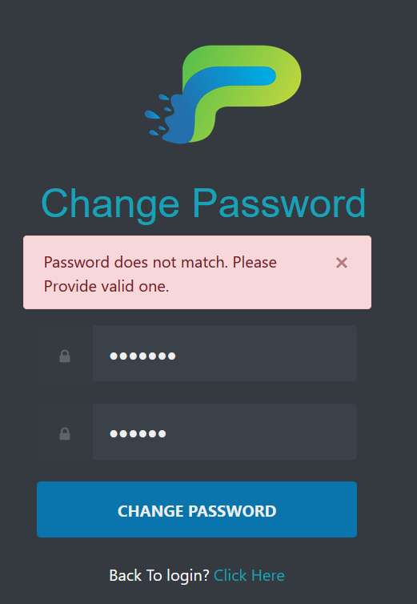

* **Registration Form**
* 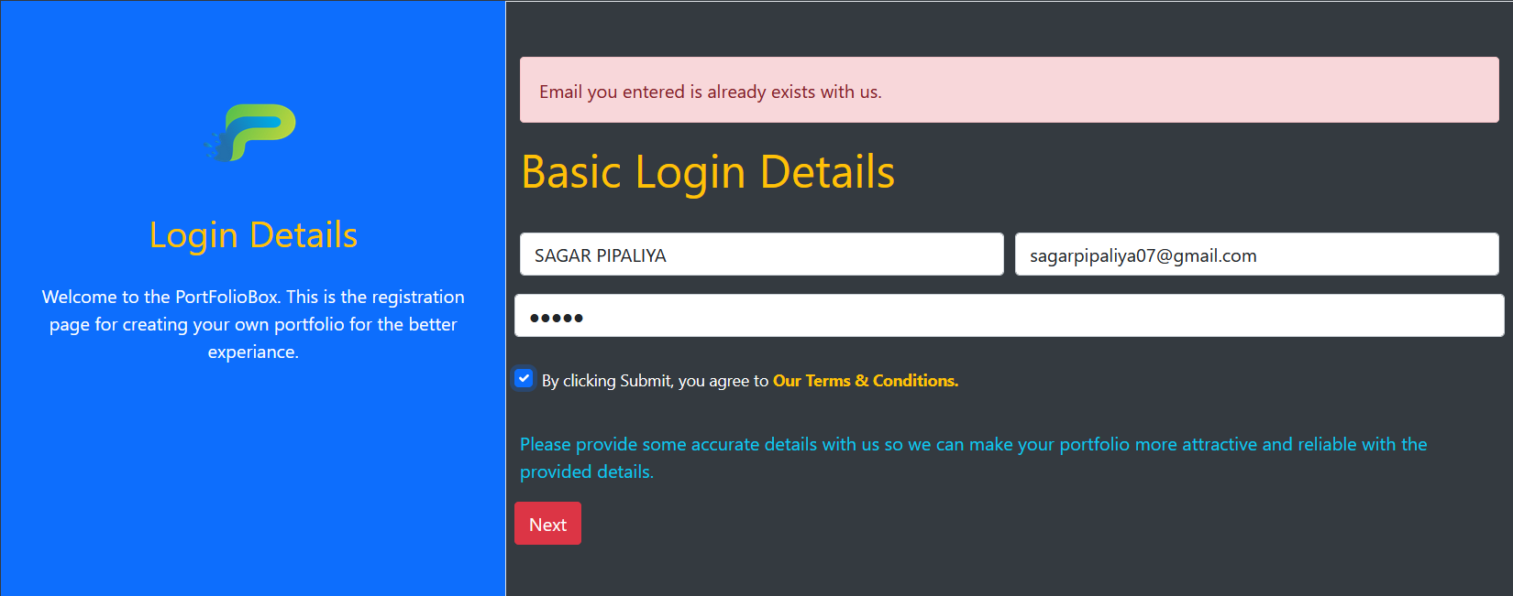**Email address already exists**
* 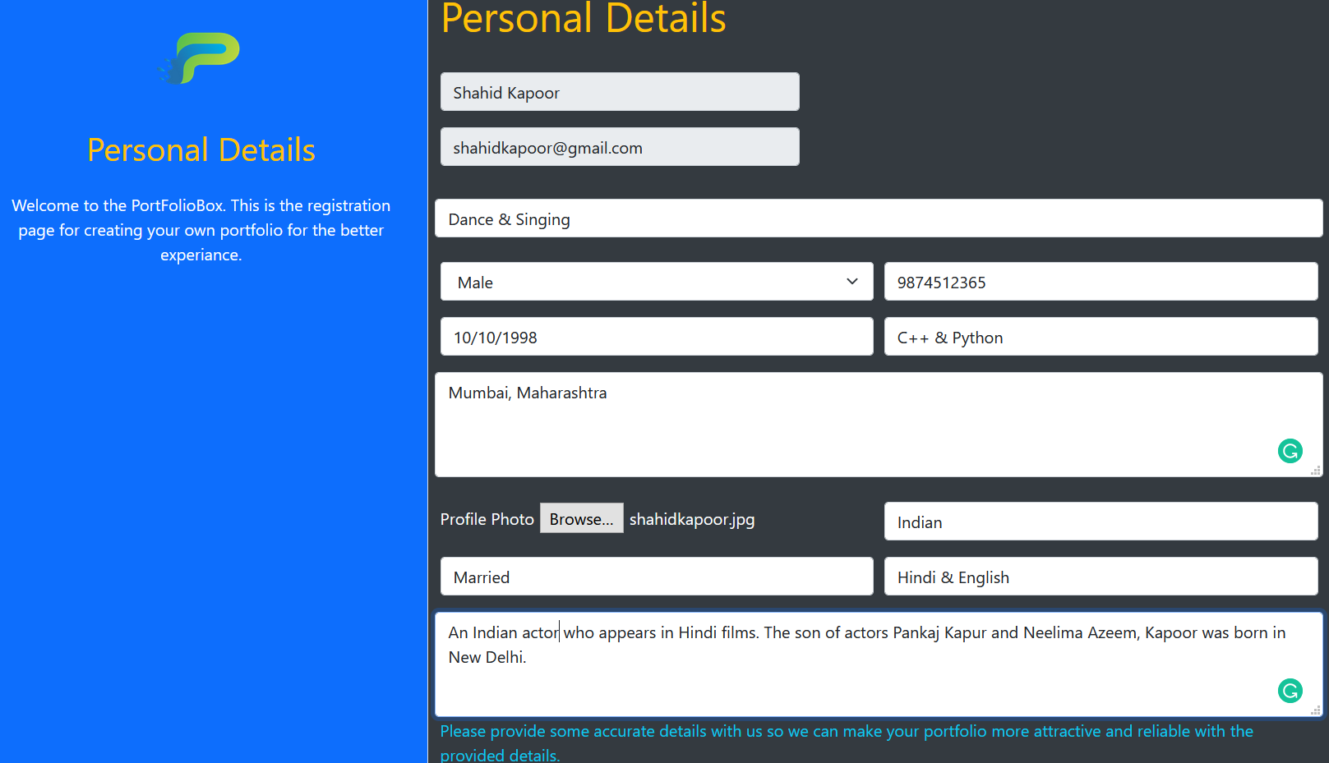**Personal Details filling**

* 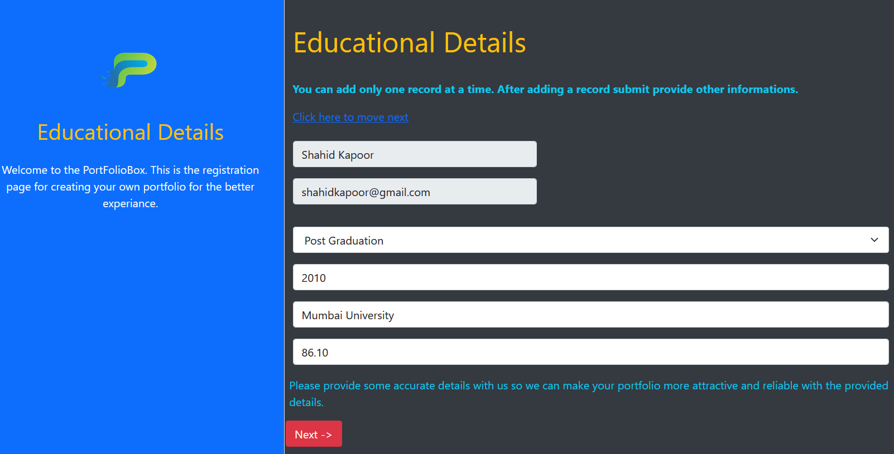**Educational Details**
* 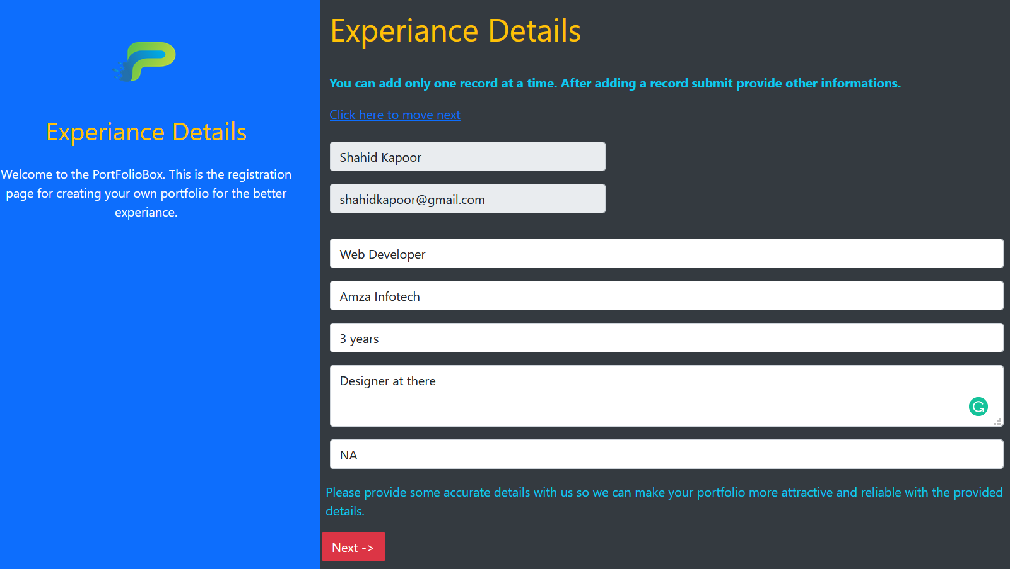**Experience Details**
* **Project Details**

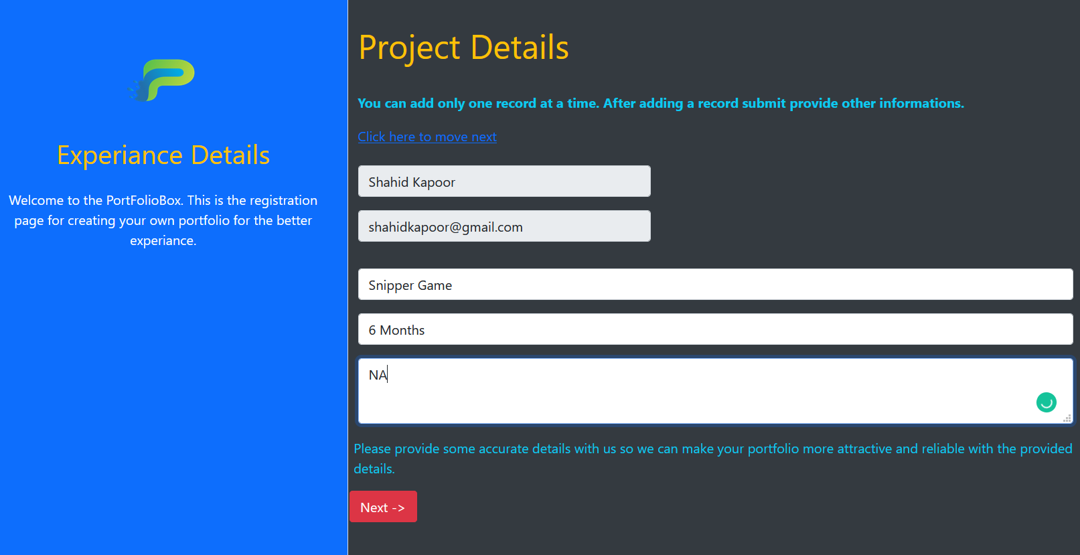

* **Achievement Details**

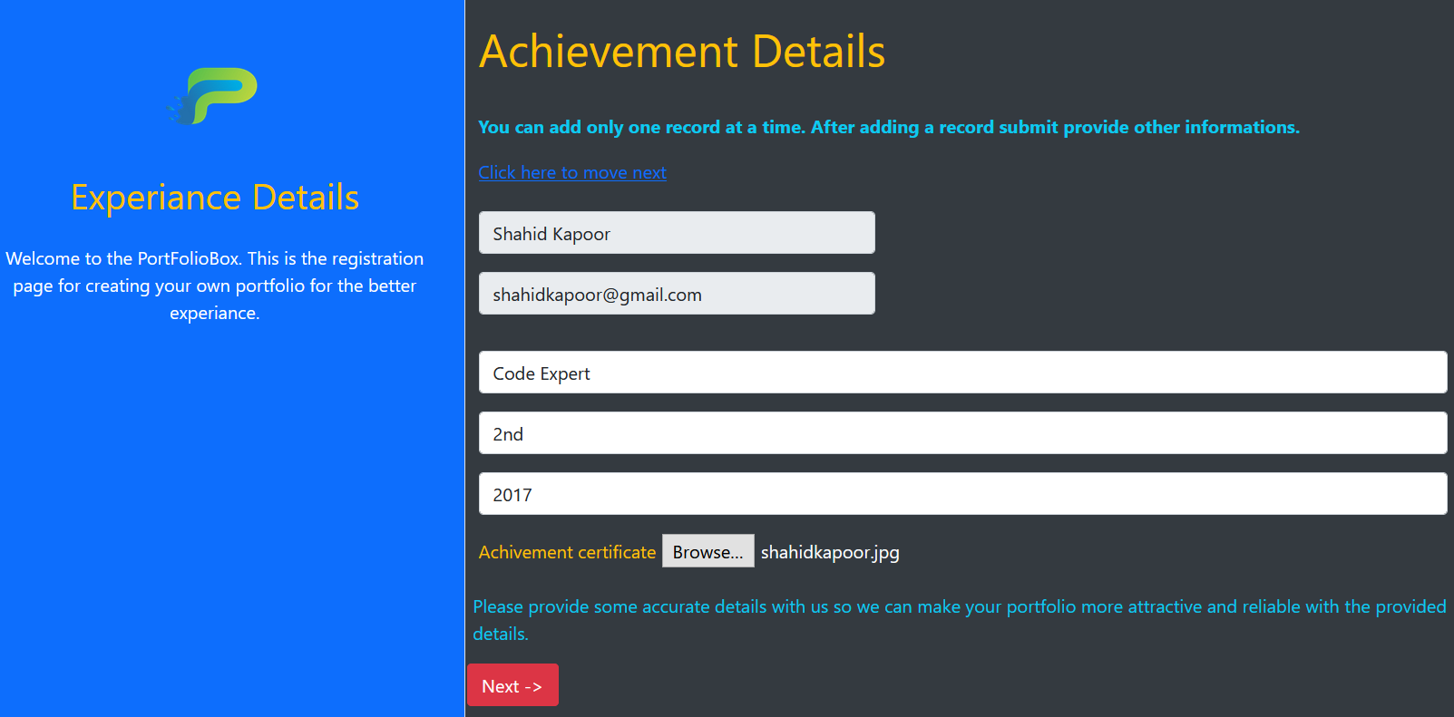

* 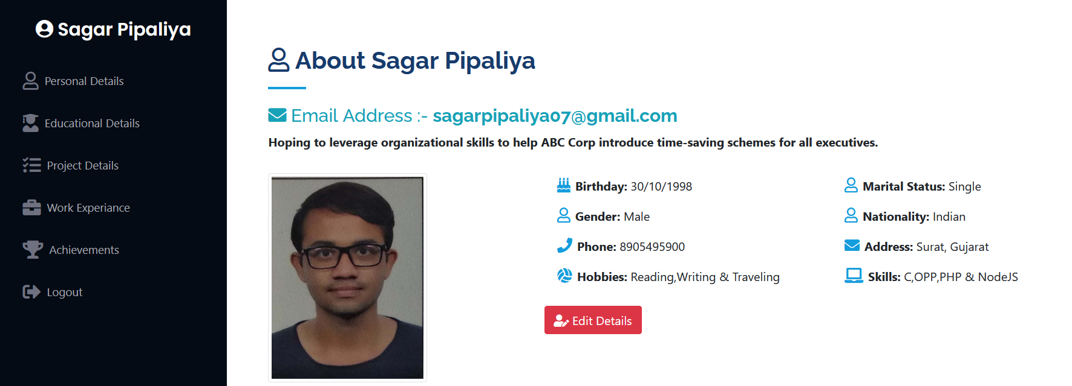**Final Resume Page**

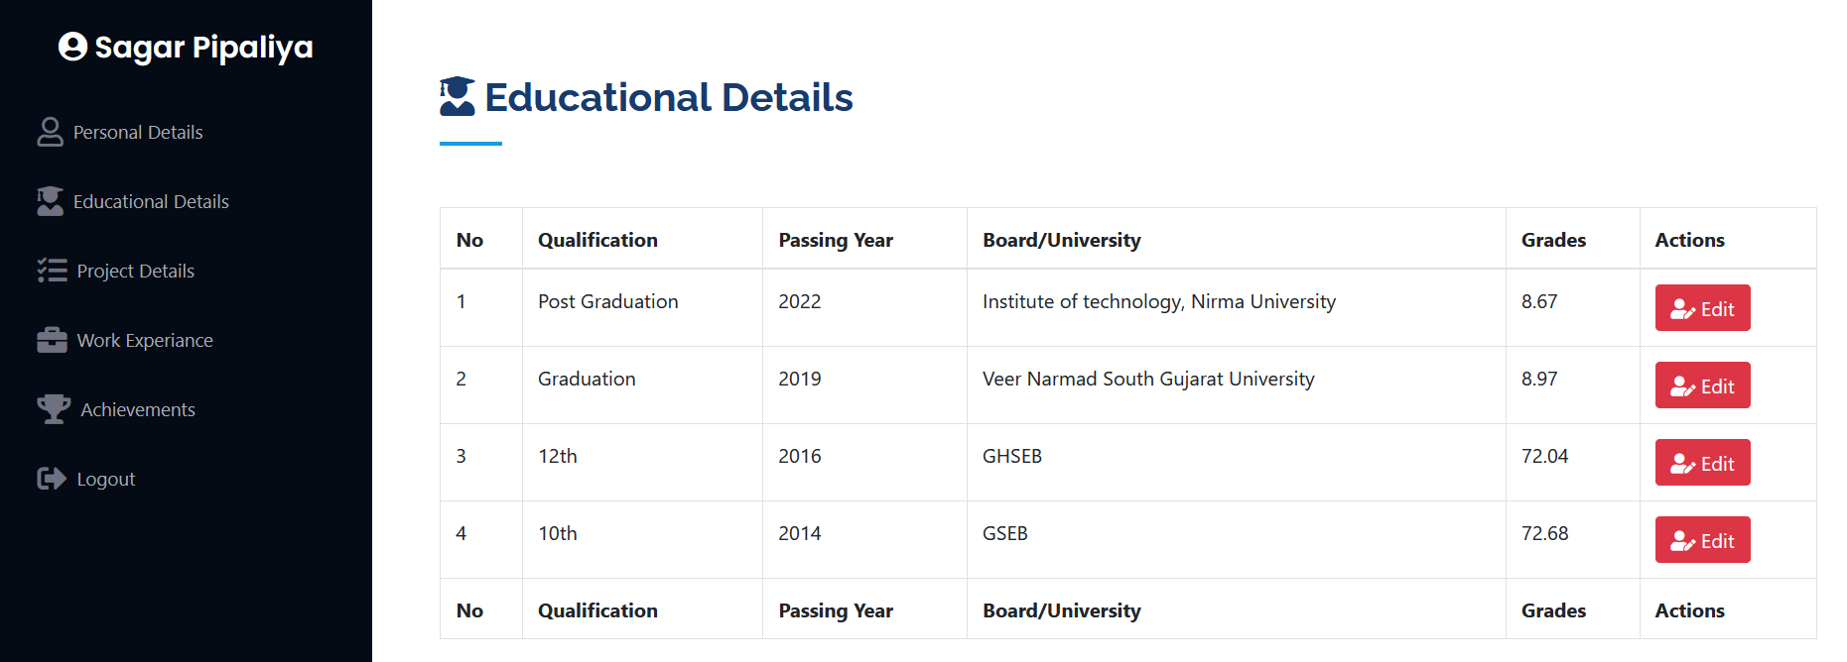

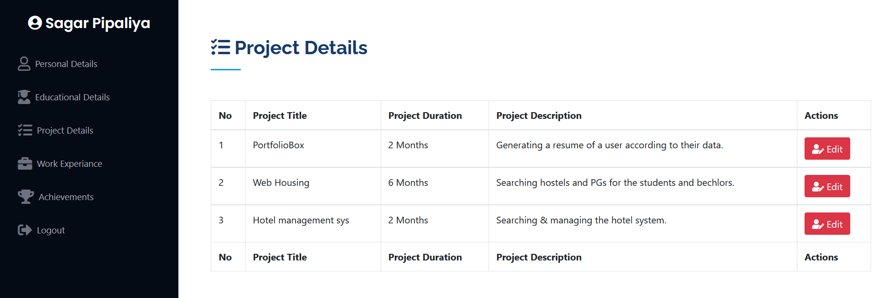

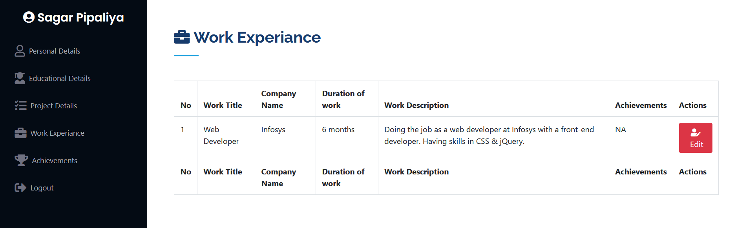

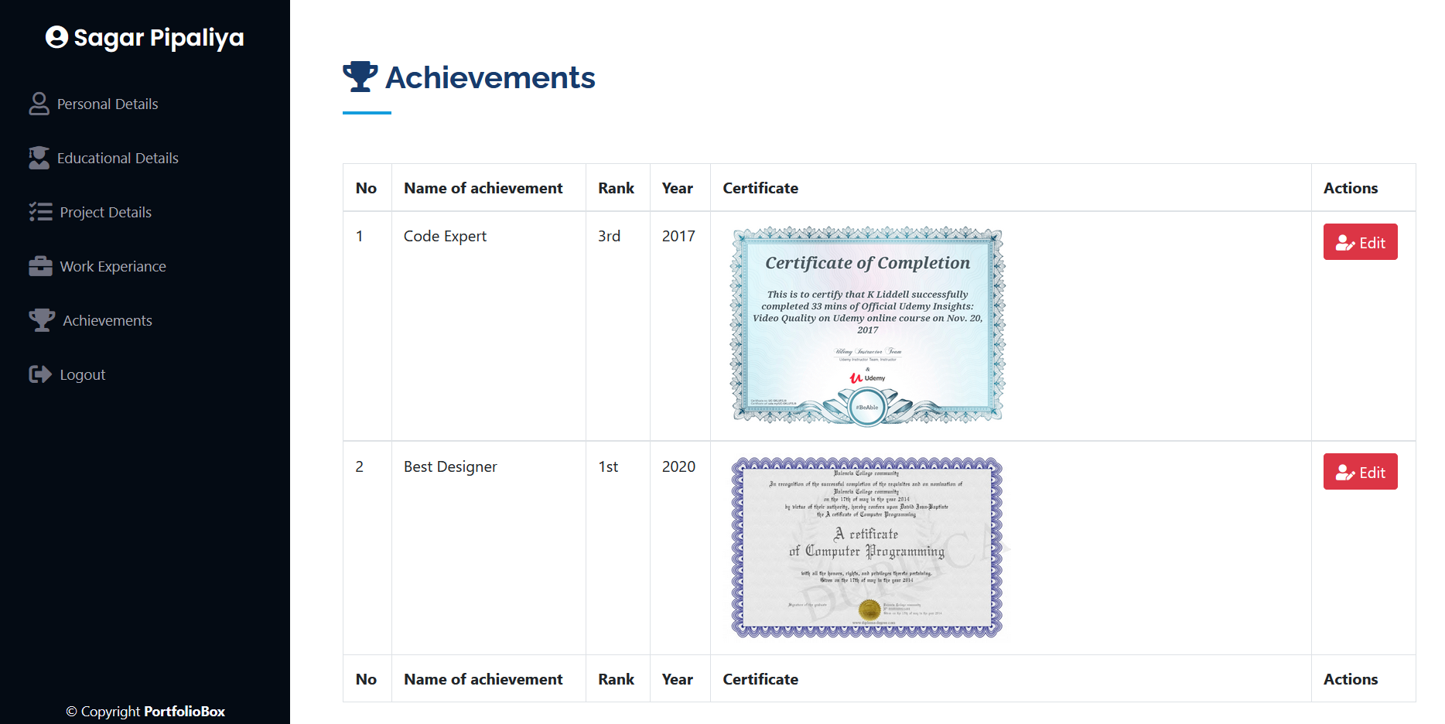

* **Changing Details in Resume**

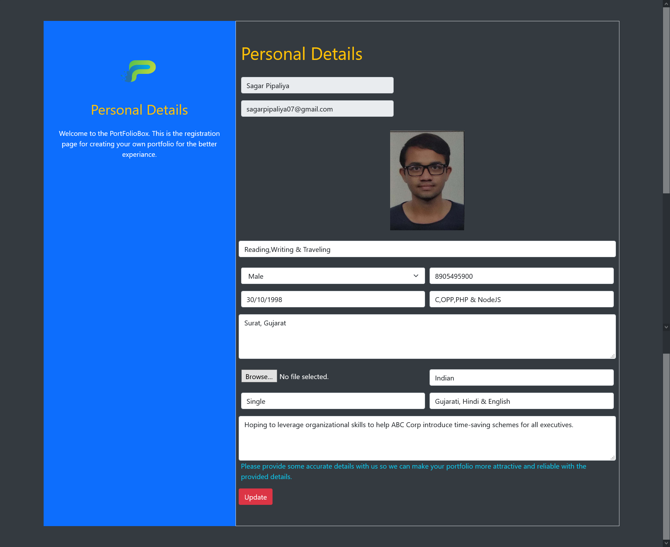

* **Updating the details**

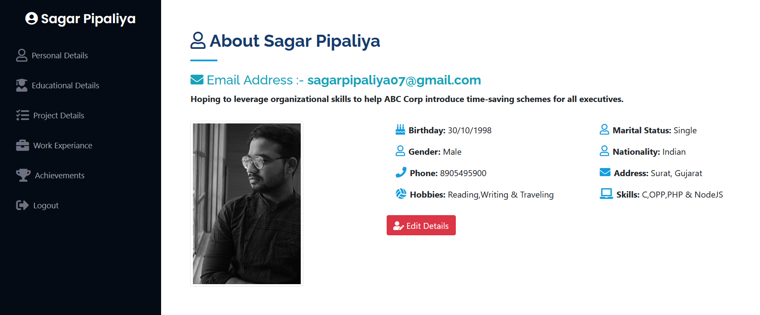

* As we can clarify that profile photo of the user has been updated with the profile and database as well.
* As follows the update procedure, all the details would be updated with the same result as shown in the image.
* **Session maintaining at user side**

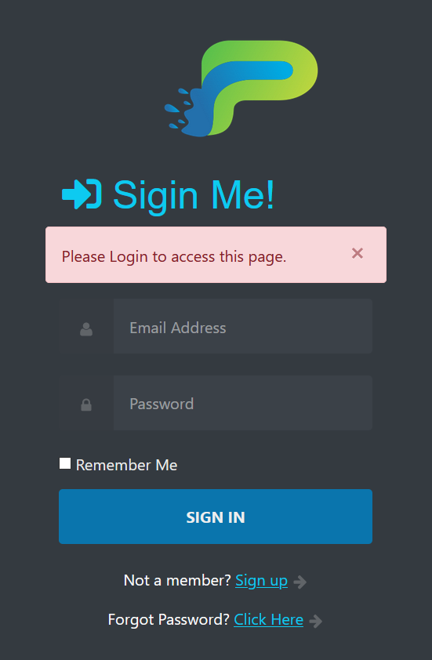

* **Remember me functionality**

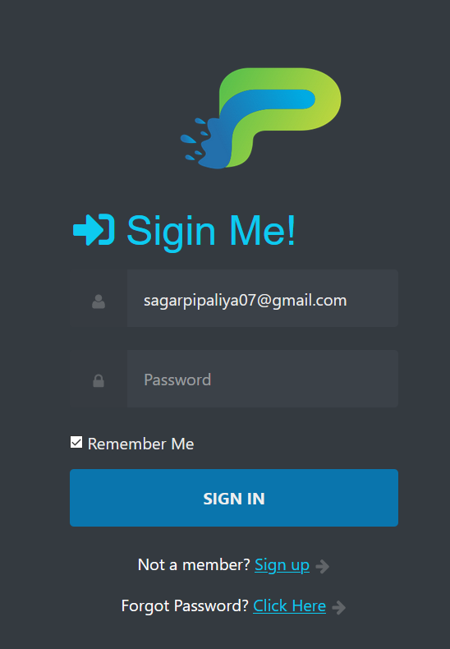

* **Admin Side**
* **Admin Login Design**

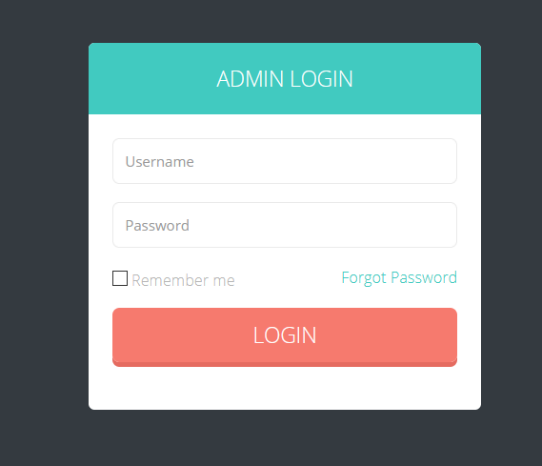

* **Invalid access to admin login**

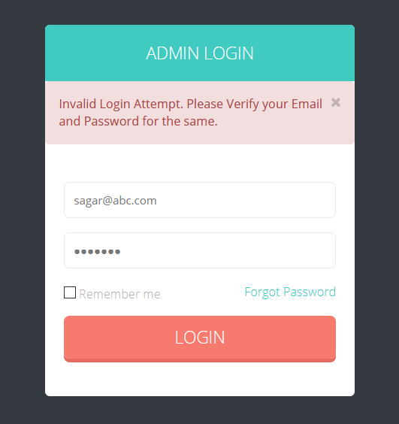

* **Remember Me**

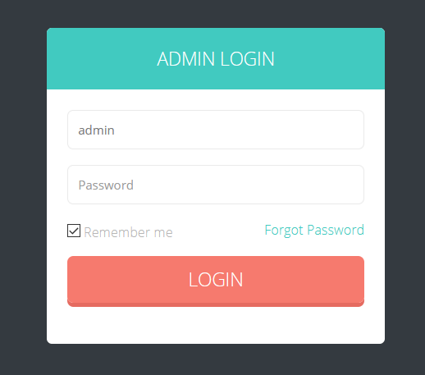

* **Forgot password (Invalid)**

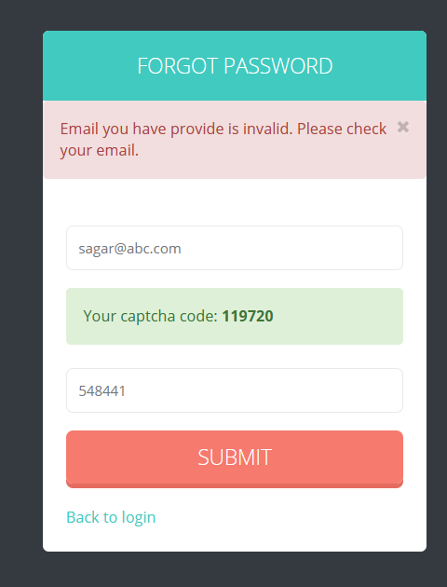

* **Entire Admin Dashboard**

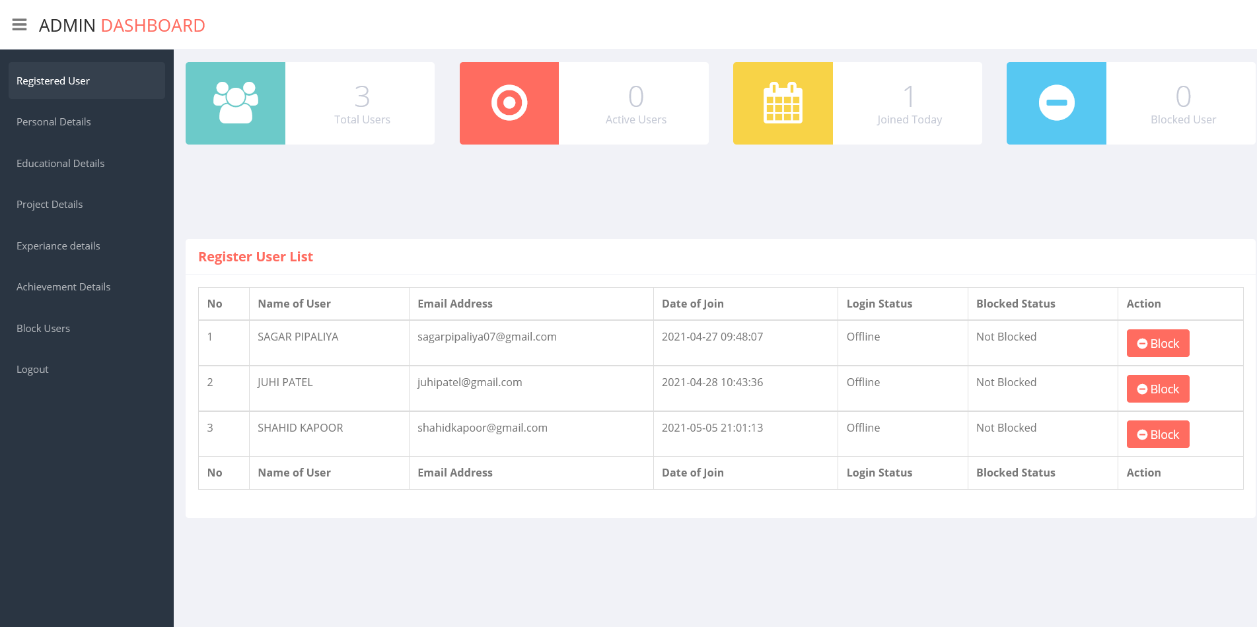

* **Personal Details of user**

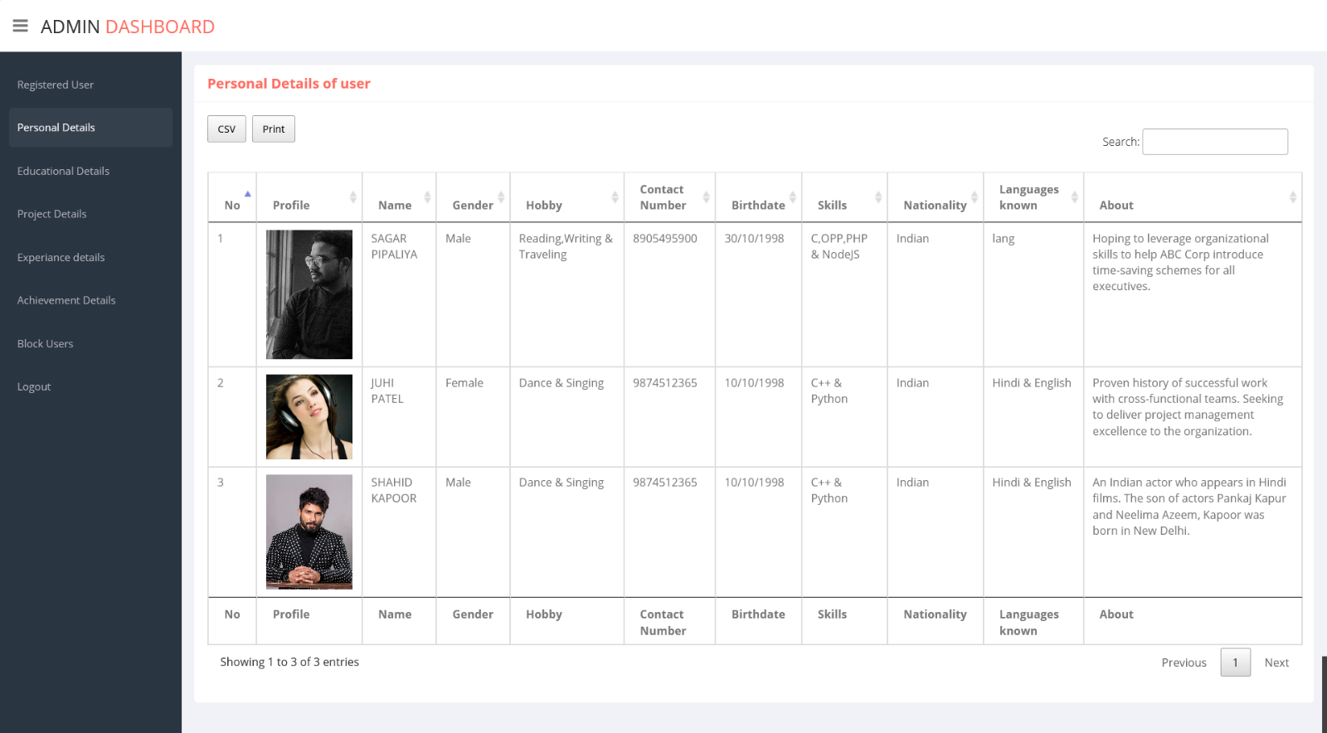

* 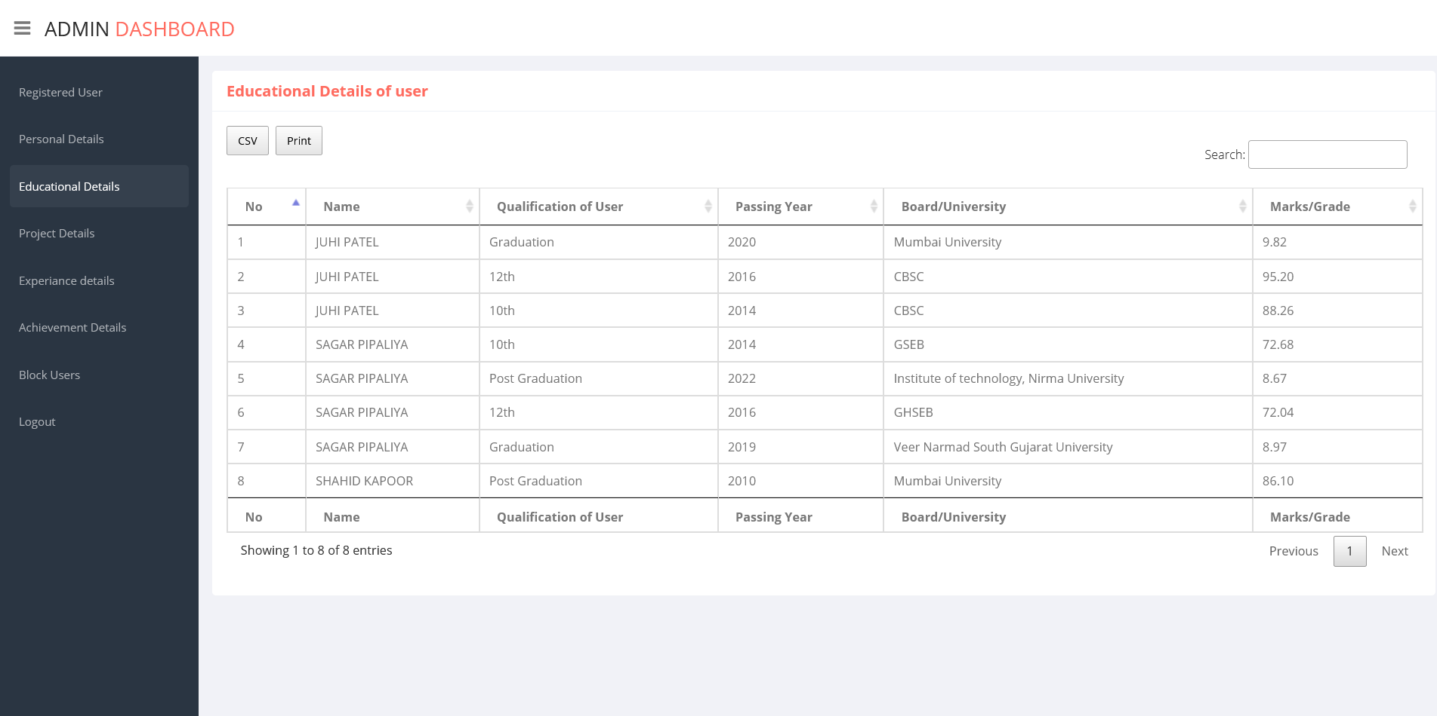**Educational Details of user**
* **Project Details of user**

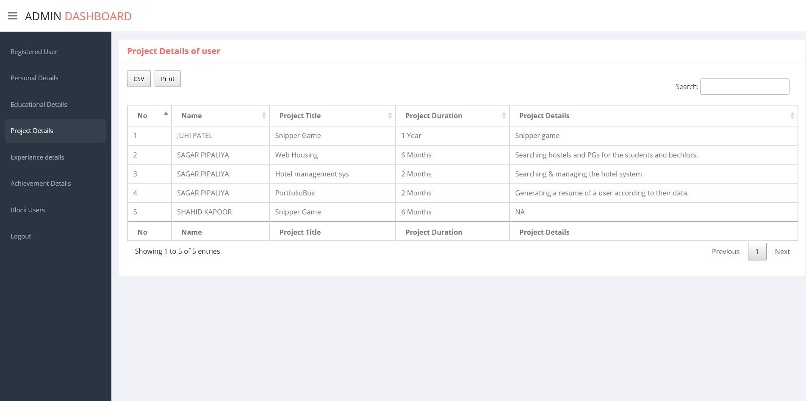

* 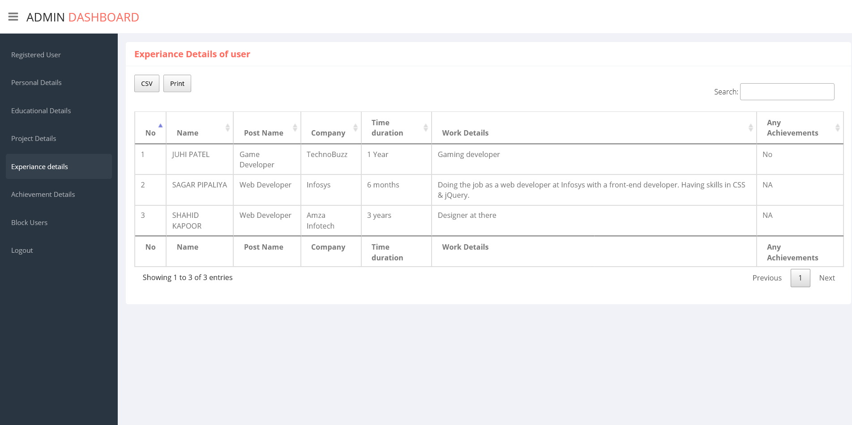**User Experience details**
* **User Achievement details**

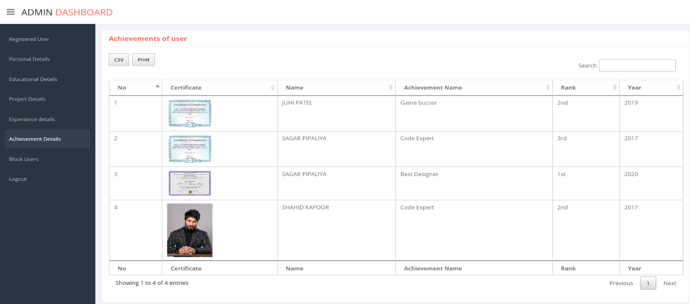

* **Generating report of a person who’s having 3 years of experience**

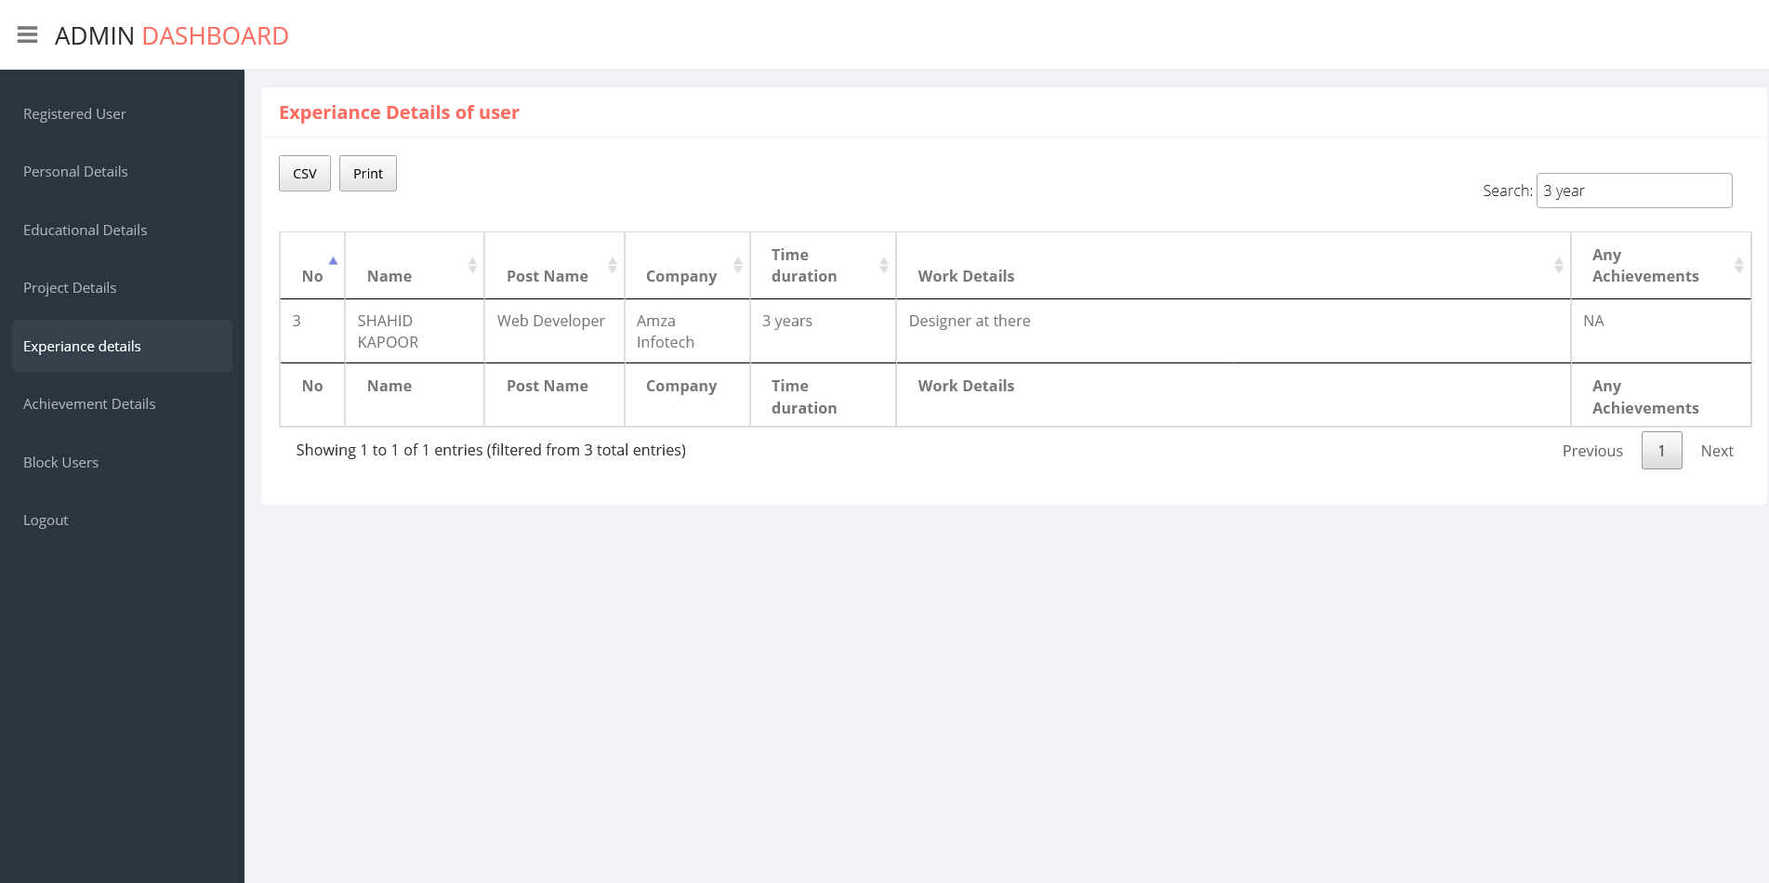

* **Download the report as PDF**

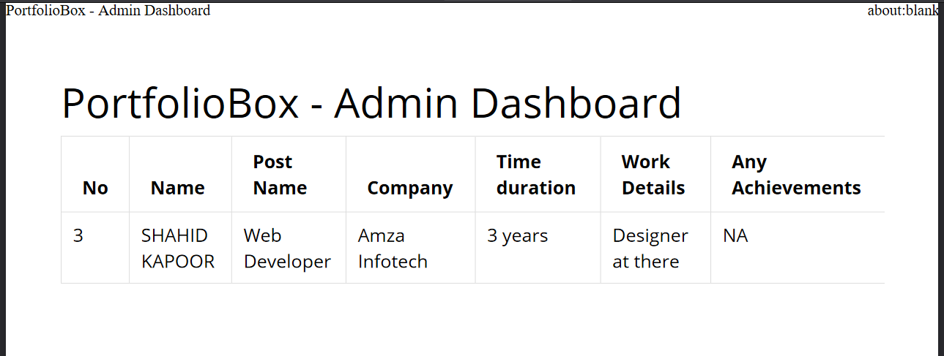

* **Download report as CSV file**

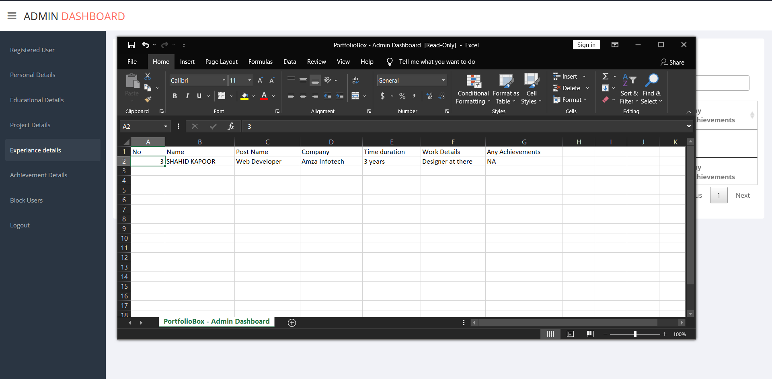

* **User Blocking System**

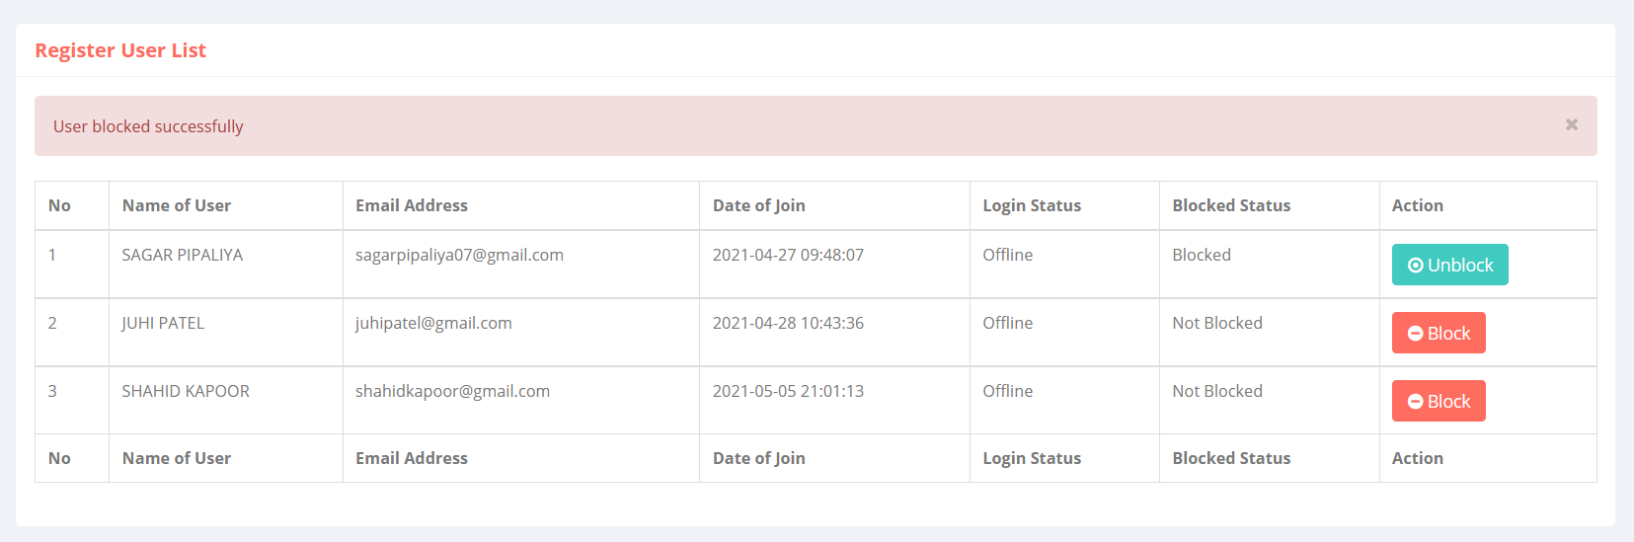

* **Generating Blocking Report**

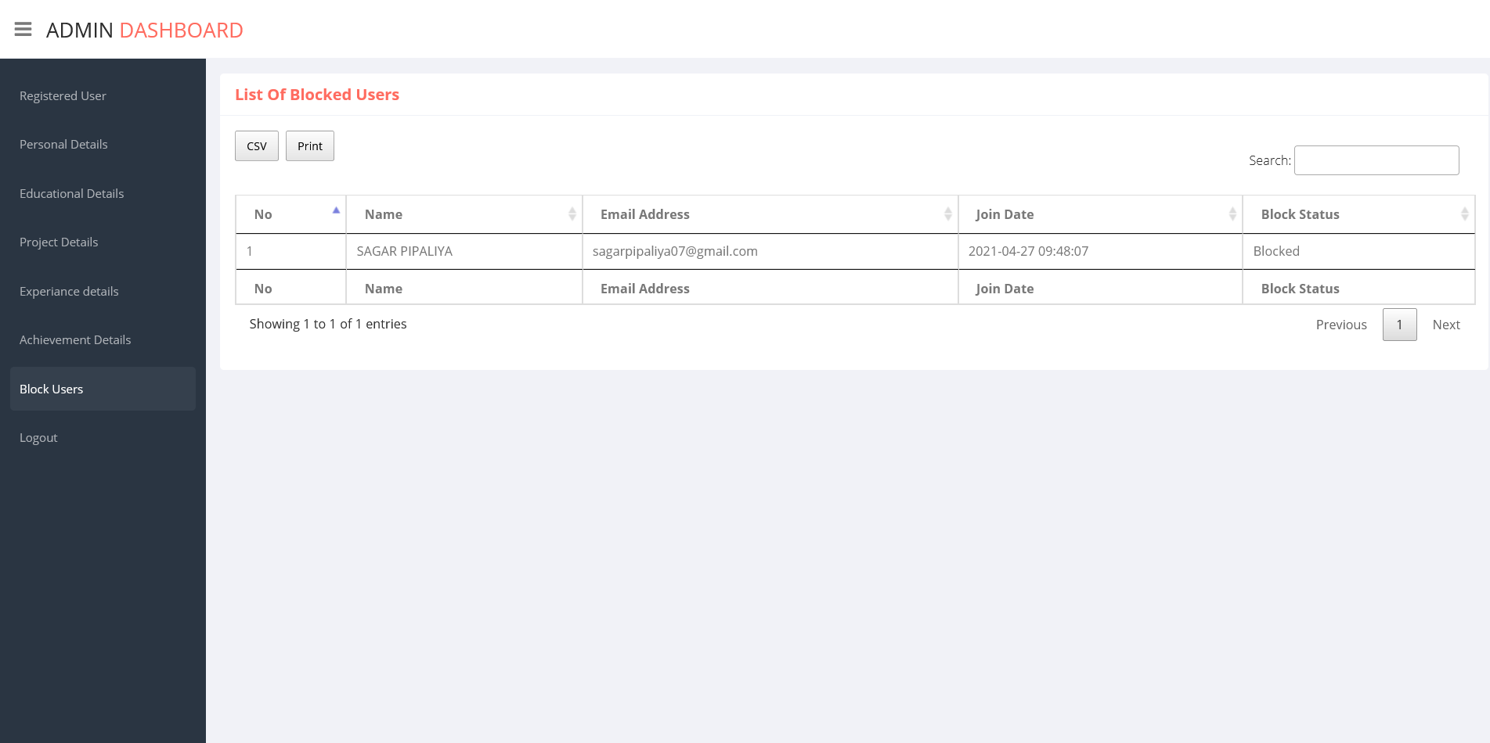

* **User is not able to login once he/she blocked**

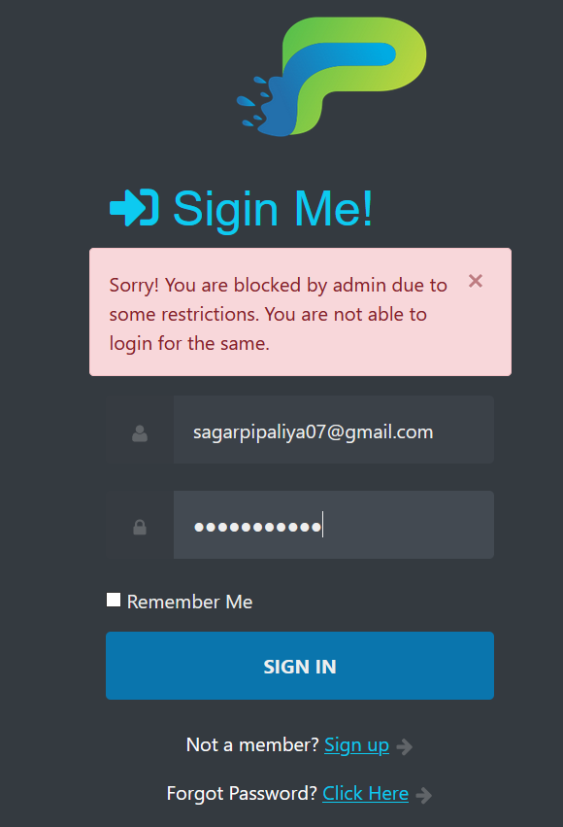

1. **TESTING PLANS**

The test-plan is basically a list of testcases that need to be run on the system. Some of the testcases can be run independently for some components (report generation from the database, for example, can be tested independently) and some of the testcases require the whole system to be ready for their execution. It is better to test each component as and when it is ready before integrating the components.

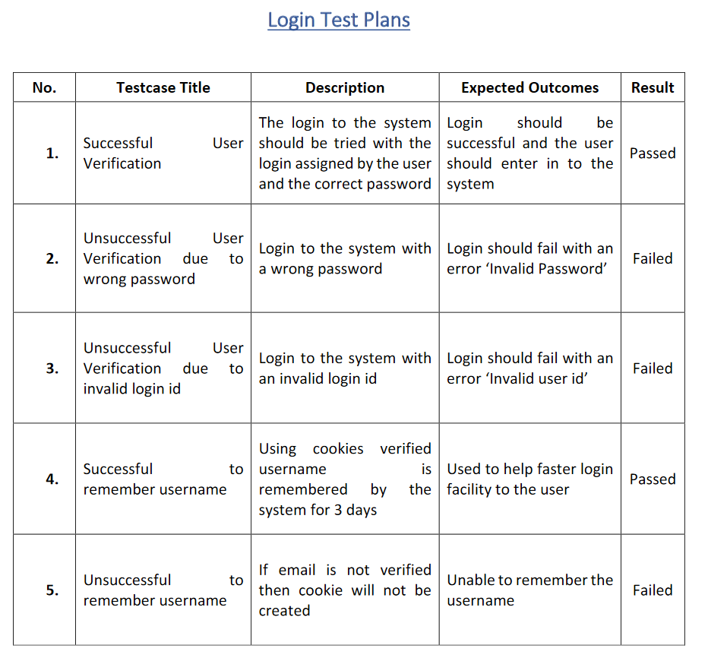

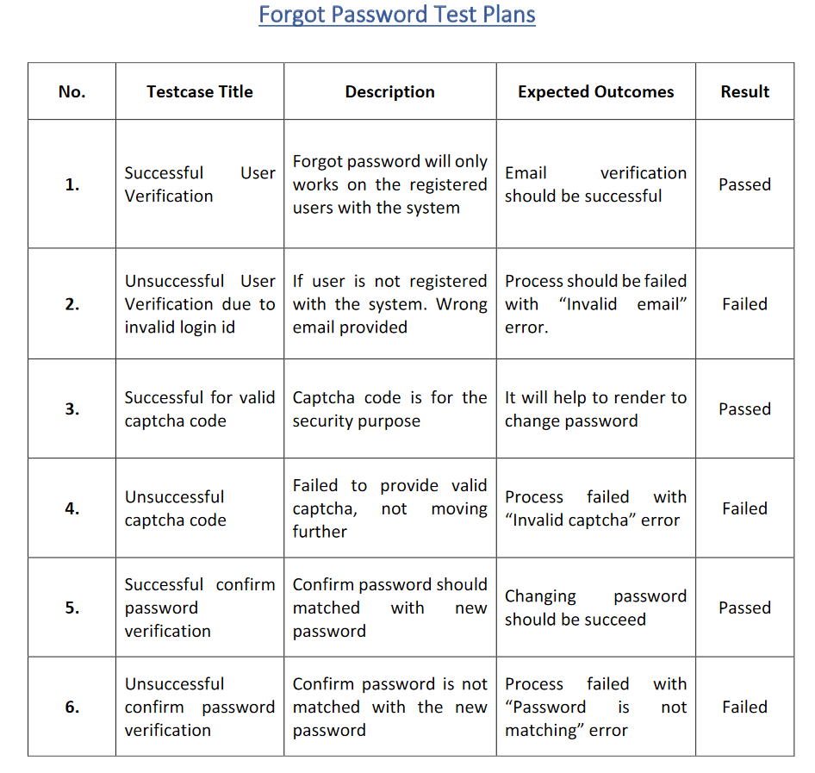

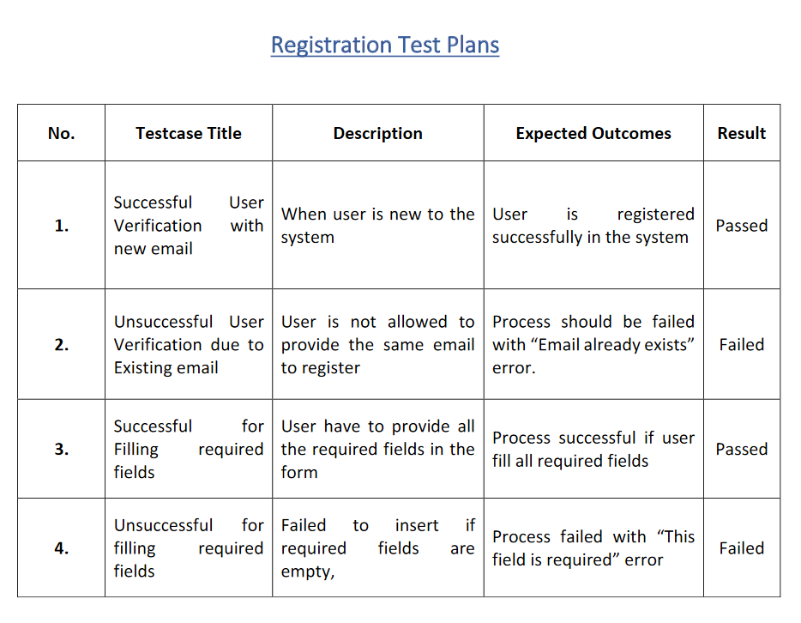

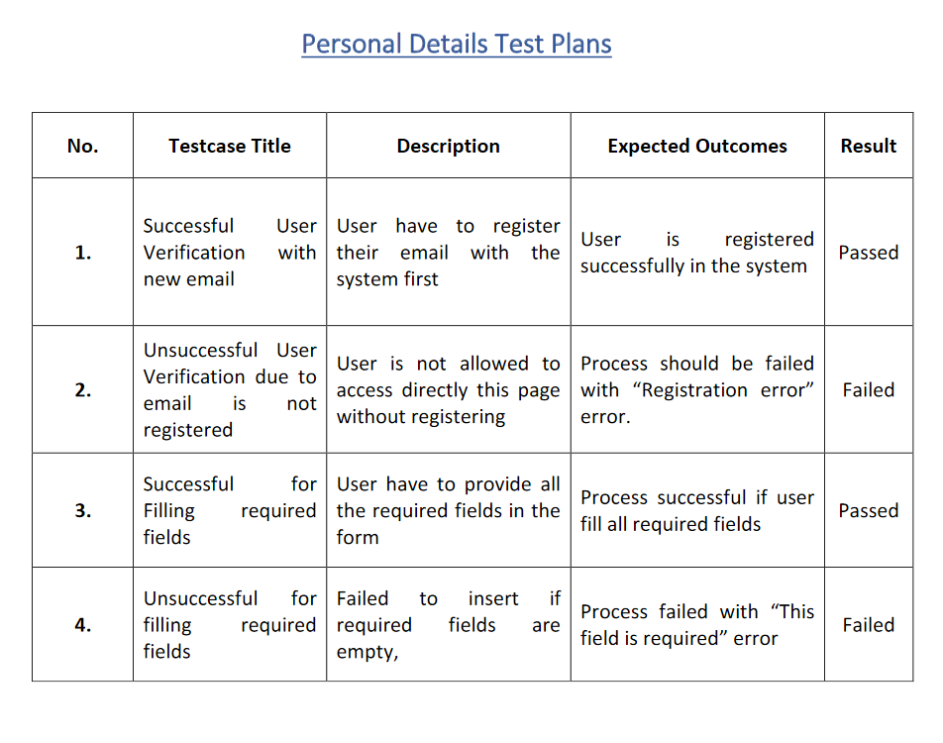

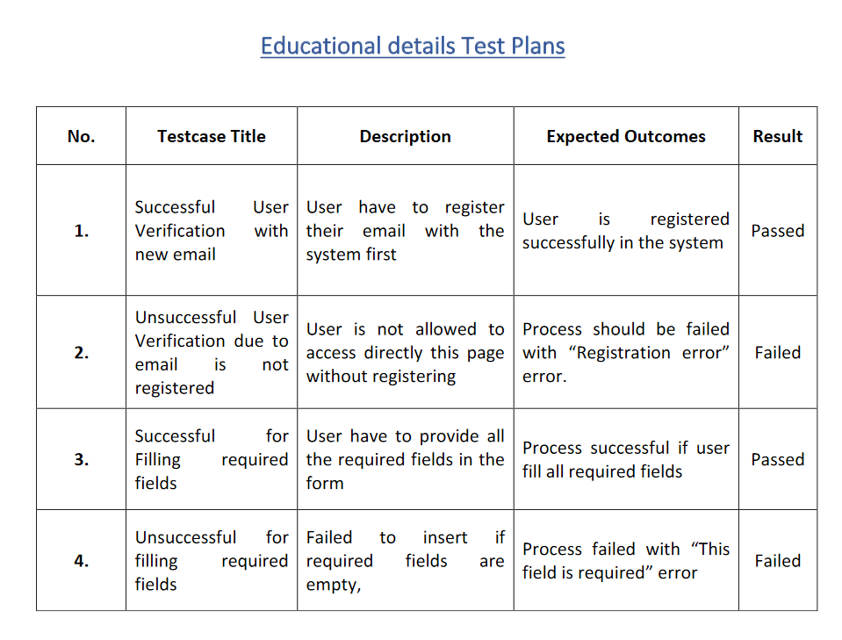

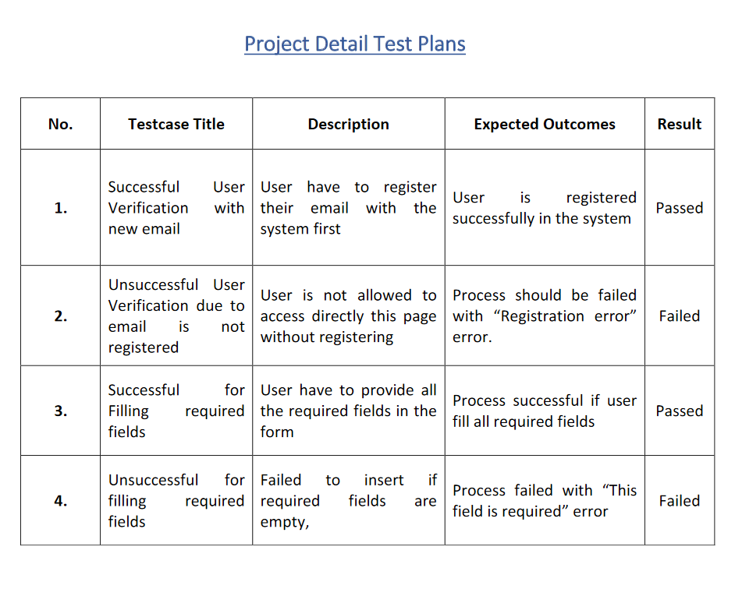

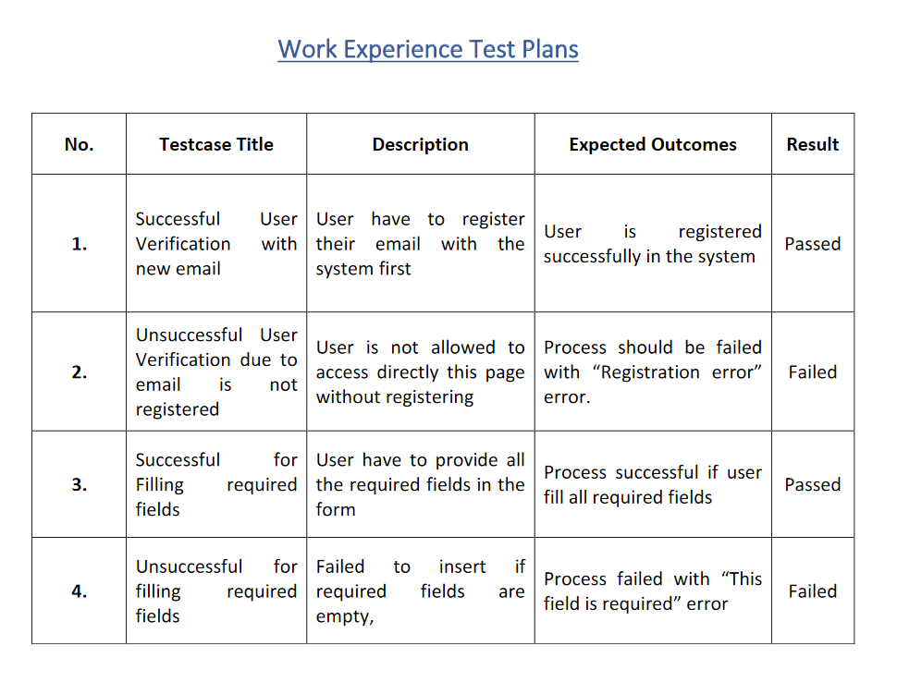

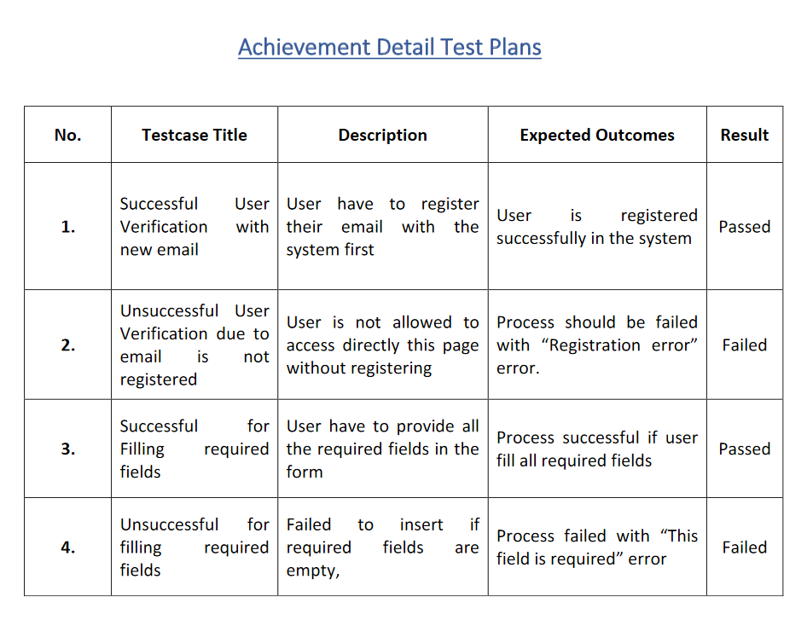

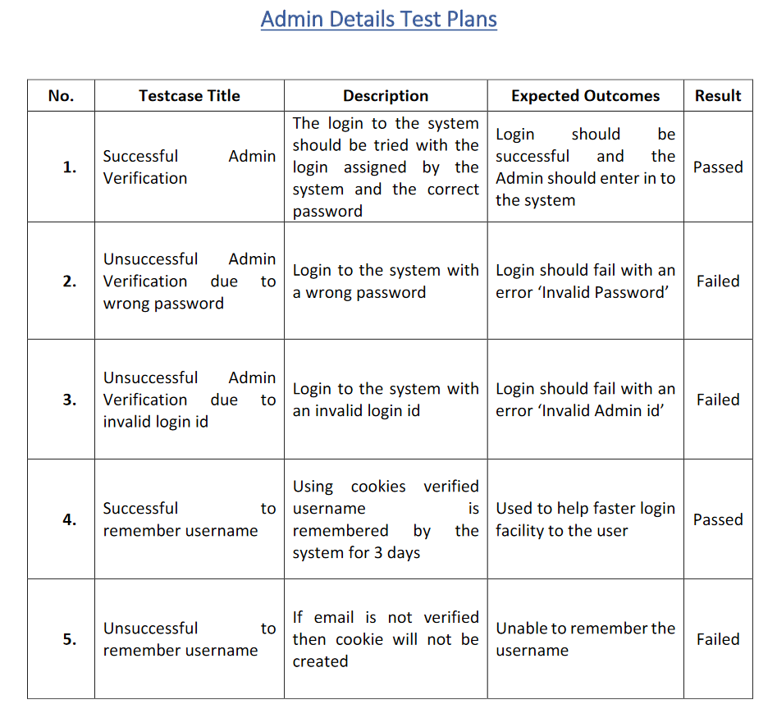

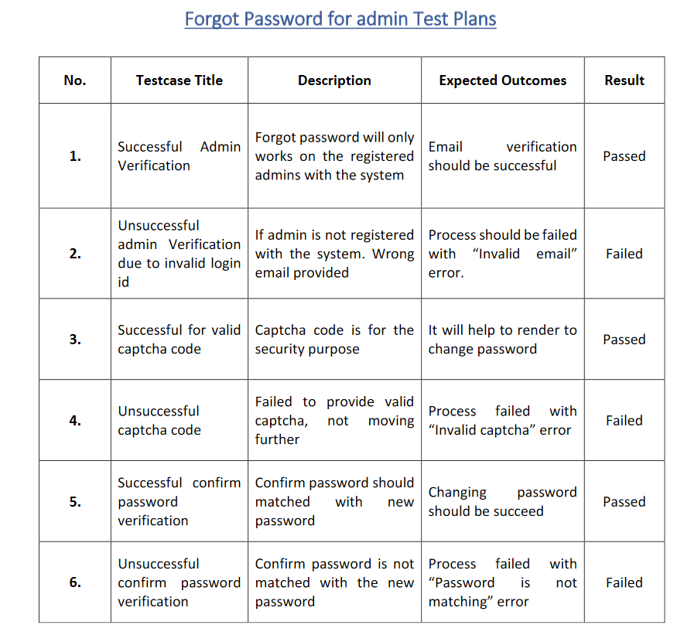

1. **LIMITATIONS, FUTURE SCOPE AND CONCLUSION**

* **Limitations of the system**
  + The major limitation of [system](https://craftresumes.com/resume-builders/) is that is they work purely online, and lack the functionality to enable the user to save a copy of their resume in other word processing software like Microsoft Word.
  + Another limitation with the system is that they mostly offer a limited choice of formats. Predesigned statements and boring, cookie-cutter templates lower the authenticity of your resume considerably.
* **Future Scope of the system**
  + The system is having currently the static base design which can be chosen by the user, according to their needs they can choose whatever resume type.
  + To increasing the system enhancement and the database security for the future.
  + Users can delete their account from the site, as they got hired or some other reasons.
* **Conclusion**
  + The portal has been successfully completed. The goal of the system is achieved and problems are solved. The package is developed in a manner that it is user friendly and required help is provided at different levels.
  + The project can be easily used in the process of decision making. Different types of reports can be generated which help the management to take correct decision and reduce the time delay which automatically increases the company’s work standards as well as the economical state of the company.
  + This system never decreases the manpower but helps the development of available manpower and optimizes the manpower by which company’s standards and capabilities can be scaled to higher dimensions.

1. **BIBLIOGRAPHY**

* HIRATION – The resume builder
* Zety – Make your portfolio
* Software engineering – Complete code (Dave Thomas)
* PHP : the complete reference (Steven Holzer)